**ONLINE SERVICES WEBSITE FOR SANTISIMA MEMORIAL GARDEN**

A Capstone Presented to ACLC College of Apalit

**Apalit, Pampanga**

**In Partial Fulfillment of the Requirements for the Degree**

**Bachelor of Science in Information Technology**

**Major in Web Application Development**

by:

**ABUAN, ERICA L.**

**LOPEZ. JERICO G.**

**MANINANG, JERWIN JAFFET**

**2022**

**APPROVAL SHEET**

This capstone entitled “**ONLINE SERVICES SYSTEM FOR SANTISIMA MEMORIAL GARDEN**”, prepared and submitted by **ERICA L. ABUAN, JERICO G. LOPEZ, JERWIN JAFFET MANINANG** was finally presented and successfully defended before the here undernamed panel of examiners on June, 2022 and is hereby accepted in partial fulfillment of the requirements for the degree Bachelor of Science in Information Technology major in Web Application Development.

**JONALYN O. GONZALES**

**JANIS S. LOPEZ, MEP-ECE**

Academic Affairs Head

Chairman and ICT Coordinator

**LORENZE CORTEZ**

Adviser

**DEDICATION**

This study is dedicated to our loving parents, brothers and sisters who have been our source of strength and inspiration to finish this study. A family who gave us emotional, spiritual, moral and financial support.

Also, this is dedicated to the research teacher/adviser of the researchers, who gave efforts and time to help and to guide them in the proper way of doing the study.

To all the friends and respondents who participated, that had gone to the successful study of the researchers.

And lastly, to the Almighty God who give us strength, knowledge, guidance and protection.

Researchers

**ACKNOWLEDGEMENT**

We would like to express our gratitude to our Almighty God for giving us strength, knowledge, and wisdom to help us in our journey to finish this study. To Mrs. Janis Lopez, our capstone instructor who patiently support and cheer us, and supplying guides in conducting of the study. For the critiques which truly made a difference to the research paper, and also for the advice which strengthened our mind and heart. To Mr. Lorenz Cortez, our capstone adviser for sharing his knowledge and guide during the process of this study. For the motivation and patience in guiding us from the preparation of the study until the end, and motivating us to be the best we can become. Our classmates, the IT- 4th year batch 2022, who helped and have been supporting us all throughout the process of making this study. Our heartfelt thanks to all.

Researchers

**ABSTRACT**

The research is entitled online services system for santisima memorial garden. The researchers have successfully made a website for online services system which the main purpose is to provide a smoother and efficient way to reserve a product for of santisima memorial garden. The Online services system for santisima memorial garden will make a big improvement over the manual system of the memorial. Customers will be able to make reservation more easily as long as there is a stable internet connection to access the website. The system might also help to improve their interaction for their incoming customers in the future. Researchers also conclude that the staff and employees will also benefit from the system because it can easily organize and manage the reservation details which make their workload less and use that time to do other work-related stuff.

**TABLE OF CONTENTS**

**PAGE**

**Title page** …………………………………………………………………………. i

**Approval sheet** …………………………………………………………………… ii

**Dedication** ………………………………………………………………………… iii

**Acknowledgement**………………………………………………………………… iv

**Abstract**……………………………………………………………………………. v

**Table of contents**…………………………………………………………………...vi

**List of tables**………………………………………………………………………. ix

**List of figures** …………………………………………………………………….…x

**CHAPTER I - Introduction**

Background of the Study……………………………………………………….……1

General Objective……………………………………………………………………2

Specific Objectives……………………………………………………………….….2

Scope and Limitations ……………………………………………………………….3

Significance of the Study……………………………………………………….……4

**CHAPTER II. Review of Related Literature**

Review of Related Literature……………………………………….……….…….…6

Local Related Studies………………………………………………….…….………6

Foreign Studies………………………………………………………………...……8

Related Literature: Regarding why we choose this Tech Stack……………….……10

Conceptual Framework……………………………………………………...………12

Definition of Terms......……………………………………………………...………13

**CHAPTER III. Methodology**

Software Life Cycle Model - Waterfall………………………………………....…16

Development Phase…………………………………………….……….…………16

Testing Phase………………………………………………………….…….…......17

Maintenance Phase……………………………………………………….……......17

Project Research Design………………………………………….…….………….17

Admin side…………………………………………………………….….…….…18

User side……………………………………………………………….…….….…19

Requirement Specifications……………………………………………….………19

Operational Feasibility…………………………………………………….………19

Technical Feasibility………………………………………………………………21

Software……………………………………………………………………...……22

Programming Languages………………………………………………………….23

Flow Chart…………………………………………………………………...……25

Budget Proposal……………………………………………………………...……34

Cost Benefits Analysis……………………………………………………………34

**CHAPTER IV. Project Technical Description**

Project Technical Description……………………………………………….……36

Software Requirements…………………………………………….….………….36

Hardware Requirements……………………………………………………......…36

Project Structured Organization………………………………………………….37

Project Limitation and Capabilities………………………………………………45

Project Evaluation…………………………………………………………...……46

**CHAPTER V. Summary, Conclusion, and Recommendation**

Summary………………………………………………………….…………….…49

Conclusion…………………………………………………………………...……50

Recommendation.…………………………………………………………………51

**BIBLIOGRAPHY**………………………………………………………...……...52

**APPENDICES**

Appendix A. Respondent Survey Questionnaire…………………………….……53

**CURRICULUM VITAE**…………………………………………………………55

**LIST OF TABLES**

**TABLE PAGE**

1 Budget Proposal Expenses………………………………........34

2 Developmental Cost…………………………………………. 34

3 Operational Cost…………………………………………...…35

4 Total Development and Operational Cost……………………35

5 Benefits of the system ………………………………..............35

6 Project Evaluation result in terms of Functionality…………...46

of the system

7 Project Evaluation result in terms of Usability……………….46

of the system

8 Project Evaluation result in terms of Reliability………….….47

of the system

9 Project Evaluation result in terms of Maintainability…….….47

of the system

10 Project Evaluation result in terms of Efficiency………….….48

of the system

**LIST OF FIGURES**

**FIGURE PAGE**

1 The Conceptual Framework...........................................….….12

2 The Waterfall/ Software life cycle model…………….............16

3 The Admin side of the Project Research Design……….…….18

4 The User side of the Project Research Design………….…….19

5 Flowchart of the Online Service Website……….............……25

For Santisima Memorial Garden

6 Homepage of Online Services for Santisima …….............….37

Memorial Garden

7 Product and services page of Online Services…………….….38 for Santisima Memorial Garden

8 Contact page of Online Services for Santisima………………38

Memorial Gardern

9 Login page of Online Services for………………..............….39

Santisima Memorial Garden

10 Sign up page of Online Services for Santisima….............…...39

Memorial Garden

11 Customer information page of Online Services.............….….40

For Santisima Memorial Garden

12 Product conformation reservation page of Online…………...41

Services for Santisima MemorialGarden

13 Product conformation reservation page of Online…………...41

Services for Santisima MemorialGarden

14 Payment summary page of Online Services…………………42

for Santisima MemorialGarden

15 Summary of selected unit and payment method…………….42

page of Online Services for Santisima

MemorialGarden

16 Dashboard of the admin side of the website......…………….43

17 Users list or the registered number of customer…………….43

To the website

18 Transactions list of the Online Services Website…………...44

For Santisima Memorial Garden

19 Records list of the website..................................………...….44

20 Live chat support of the proposed website........…………….45

**CHAPTER I**

**BACKGROUND OF THE STUDY**

Today, websites are the best way to publicize and disseminate information to the utmost number of individuals in the world. The Internet is a technology for organizations providing means to communicate with the public. It also has the only one characteristic without geographical boundary or time limit, everyone interacts through one-to-many or many-to-many networks meeting matches to do business and provide or request services they want.

COVID-19 is an unprecedented, physical distancing, and quarantine measures were mandated. In an effort to meet this mandate while trying to maintain the status quo, various types of technologies shifted from offline to online, resulting in an accelerated demand of emerging digital technologies. The majorities of organizations have a website with their policy and their artefact and service information. It is perhaps the mainly economic and the most suitable way to disseminate information and data all over the world. Due to advancing strides and rapid changes, computer trends had surfaced.

Many are dying due to the current pandemic, which is why memorial lots are one of the mainstays of families. Demand is increasing and many are investing and buying memorial lots. for this reason, Santisima Memorial Park wants to have their own web-based system to facilitate their customers in a much efficient way.

**GENERAL OBJECTIVE**

The main objective of the study is to create an Online Services Website for Santisima Memorial Garden to develop the marketing transactions of this company and the main purpose of the proposed website is package reservation.

This website provides a map for clients to easily locate the lot location and reserved the package or services.

This study aims to improve the current system they are using which is the manual system and it will give convenience to the clients without visiting the location.

**SPECIFIC OBJECTIVE**

This study aims to develop a system that integrates:

1. Package and Services

1.1 Reservation

1.2 Package Detailed

1.3 Available Lot

2. To provide better transaction by using:

2.1 GCASH

3. To provide effectiveness of the system that measured in term of the following:

3.1 Functionality

3.2 Reliability

3.3 Usability

3.4 Security

**SCOPE AND LIMITATION**

**SCOPE**

The general focus of this study is to develop a website that will help the company and clients as well. The purposed website which is the ONLINE SERVICES WEBSITE for SANTISIMA MEMORIAL GARDEN can provide memorial lot availability for the customer that will help them to choose without going to the physical site. This will benefit both clients and the Santisima Memorial Garden because it will help the memorial staff and personnel to prepare the contract or papers of their incoming clients. If the clients or customers have more concern but it is hassle for them to come to the physical site, they can directly message through the website by using real time chat support. Aside from online reservations, the system can also manage walk-in customers and records their reservation or payment details in the system. The reservation can only be confirmed once the customer already paid the required amount for their reservation. For online payments is only accepting Gcash as the payment method in order to complete the process of reservation.

Online Services Website for Santisima Memorial Garden is composed of the following sections of the system:

1. **Accessible reservation**. The suggested system focuses on Internet advertising, reservation and marketing of Online Services System. Customers can choose the type of lots they want using the website.
2. **Package selection**. Customers can also view product or package details in person or online using their device with a web browser and internet connection. The system will handle the reserving and marketing of products via the internet.
3. **Fast and Secure**. Another goal of the suggested systems is to speed up the company's transaction and ensure that its consumers are satisfied with its products and services.
4. **Online Payment Method**. The Online Services Website for Santisima Memorial Garden is convenient in terms of payment method because it integrates Gcash as payment that can be done online which correlates to faster and efficient payment especially during this Pandemic.

**LIMITATION**

The system does not have the ability to reserve any kinds of services this only offers memorial packages. Customer can only reserve the package offered through the website. the costumers are required to create an account and the system only allows customers who have registered to check and access their accounts

**SIGNIFICANCE OF THE STUDY**

The developed Online Services Website for Santisima Memorial Garden will be of great help to the following:

**The organization**, as overall impact the website will help its customers, staff, and future researchers are all seen as target users who will profit from the system deployment.

**The company**, this will help the company to gain from the adoption of a system since it will be able to improve its business through online exposure. Employees or individuals can work more efficiently and become more accessible to potential clients. Inquiries and unique demands of clients can be serviced through the system, resulting in a rise in customers and improved marketing and sales.

**Customers**, particularly those who live outside of the city, can profit from the usage of an online system. Their questions and preferences for memorial service packages can be easily met.

**Employees**, this will help the employees to benefit from the system since it will make it easier and faster for them to complete their tasks accurately.

**The Proponents**, have learned how to use their knowledge and programming skills to the building of systems as a result of the study.

**The Future Researcher**, this study will be used as a model for future research of a similar sort.

**CHAPTER II**

**Review of Related Literature**

This chapter includes a compilation of related topics and studies that are relevant to online reservation systems.

**LOCAL RELATED STUDIES**

**658 Apartelle Online Reservation System.**

**As stated by Bituin Abi, (August 2010)** The 658 Apartelle Online Reservation Management System is not only a database for a guest list but also an online reservation system, where potential guest can have an online reservation which will automatically be sent to the database of the 658 Apartelle. Problems related to time-consuming log-in among guests to the log book; difficulties in making reservations; and difficulties in retrieving information of the previous guests were found.

**Bacolod Online Showroom**

**According to Ronel Pacite (March 2014)**, Bacolod Showroom was utilizing a traditional and manual process. Since its operation, it had encountered a lot of problems when it comes to reaching out to more customers, especially for those out of town. Customers have no access to their products since there was no website where they can visit or browse. Bacolod Showroom found difficulty in updating their sales reports, and there was no system for monitoring the incoming and outgoing of products.

**Marsman Drysdale Travel INC. (MDTI)**

MDTI is one of the best travel and tours Company in the Philippines. MDTI was established in 1975 due to lack of tourist industry here in the Philippines. Located in the Makati Business District as their head office, MDTI operates all over the country.

MDTI are served to give quality services and products to the customers. Keeping their moral, professional, ethical standards in their operations, making great leadership in the business travel industry and honesty as they could meet the customer needs. The system will allow clients to look for the available services of the company with the use of online reservation.

MDTI reservation system is similar to the proposed system of the proponents in terms of minimizing data redundancy, inconsistency on data in reservation, and reducing paper works. Nowadays internet and computer have big parts in their daily lives because it makes their work faster. The clients could also save their time and effort by booking online.

**Boracay Grand Vista Resort and Spa**

The Boracay Grand Vista Resort and Spa has an online reservation system. It includes the supervising of schedule, reserving facilities and rooms, guest information and confirmation of the guests if they are sure to reserve some rooms. Customers do not need to create an account if they want to go to the resort or to make a reservation.

Similarities of the proposed system includes reserving of the facilities and rooms in the resort. Unlike the proposed system, the customer is required to make an account in order to make a reservation or cancel a reservation. Making an account will help the company to make sure that the customer’s personal information is secured and the company will be able to monitor the regular customers.

**FOREIGN STUDIES**

**Online Business Advantages**

**As stated by Zhenya Beck at centauria.com (Oct. 21, 2012)**,“Advantages of going online: Powerful, fast and efficient marketing and communication tool and medium, telecommuting reduces the number of cars and car miles, Very inexpensive way to reach new markets and interact with them, Office & transportation cost savings, Unlimited possibilities for automation of your business, you can automate your order and payment processes, your customer support tasks and more, Global presence 24/7.”

**Advertising and Marketing**

**According to Paul J. Dowling, Jr. (Oct. 21, 2012), at referenceforbusiness.com.** On the Internet, a small, one-man operation can look as good or better than a large, multinational corporation. But whether it’s an individual working out of a virtual office, or a CEO sitting in an expensive downtown office building, they’re going online for one purpose—to sell. And they’re leaving no stone unturned in their efforts to make it safe and easy for their customers to buy. ” retrieved Oct.

**Louw, Door Janne, (2006, May 10, 2006)**

Description with UML Hotel Reservation System. Developed a hotel management system that can be used online. This system allows the guests to do their booking online by them self. Some of task that the system can do are providing a query for arriving date and the length of staying, providing the number of On rooms, view all available rooms and provides user the ability to choose one or more of them, recording the number of on rooms, view all available rooms and provides the user the ability to choose one or more of them, recording kind of guests and how many going to be in the single room, providing the cost of booking, asking the users if they want additional service; such as, dinner or breakfast, storing the guests detail; like, name, address and telephone, asking the user for confirmation, final confirmation views with the detail of booking and the guests can review or cancel the booking.

The proponents’ system also allows the client to do their booking online and make transactions by them self. The proponents’ system also provides a query for arriving date and departure date, view all the rooms and let the user choose what kind of accommodation they want. Unlike UML Hotel Reservation System, the proponents’ system does not include additional services; such as, dinner or breakfast.

**Tracking Online Reservation History with the Billing Utility**

The Hudson Group Knowledge Base was designed for clients of The Hudson Group and their suite of transportation management applications. The Knowledge Base provides many quick self-help answers to common or frequently asked questions. Using the online Billing Utility, Hudson clients who accept reservations from the HWeb Reservations System, can view the history of reservations that are recorded online for a single day, week, month, or other period of time. A common use of the billing utility is to obtain statistical data for online reservation system, useful when reviewing monthly statements from the Hudson group reflecting totals for reservation recorded online.

Similar to the study, the proposed system will be able to track down the weekly, monthly and yearly reservation. This will help the management to monitor the rates of sales of the resort.

**Related Literature: Regarding why we choose this Tech Stack (programming language)**

**Front End**

CSS or Cascading Style Sheets was first developed in 1997 as a way for web developers to define the look and feel of their web pages. It was intended to allow developers to separate content from design so that HTML could perform more of the function that it was originally based on the markup of content, without worry about the design and layout. This programming language will be responsible for placing the data being uploaded to the website in their proper places.

Bootstrap is the most popular HTML, CSS, and JS framework for developing responsive, mobile first projects on the web. Bootstrapping usually refers to the starting of a self-sustaining process that is supposed to proceed without external input.

HTML or HyperText Markup Language is the standard markup language used to create web pages. XHTML or Extensible HyperText Markup Language is a family of XML markup languages that mirror or extend versions of the widely used HTML, the language in which Web pages are written. These are the programming languages that are going to be used for the development of the front end of the system.

**Back End**

PHP is a server-side scripting language designed for web development but also used as a general-purpose programming language. PHP code can be simply mixed with. HTML code or it can be used in combination with various emplacing engines and web frameworks. The PHP code is usually processed by a PHP interpreter, which is usually implemented as a web server native module or Common Gateway Interface (CGI) executable.

MySQL is the most popular database system used with PHP. MySQL is a database system used on the web. It is a database system that runs on a server. It is ideal for both small and large applications. MySQL is very fast, reliable, and easy to use. It supports standard SQL. It compiles on a number of platforms, it is also free to download and use. MySQL is developed, distributed, and supported by Oracle Corporation.

**Conceptual Framework of the Developed System**

This section shows the preliminary understanding on how the proposed project is to be develop It is incorporated with the Input, Process and Output.

**CONCEPTUAL FRAMEWORK**

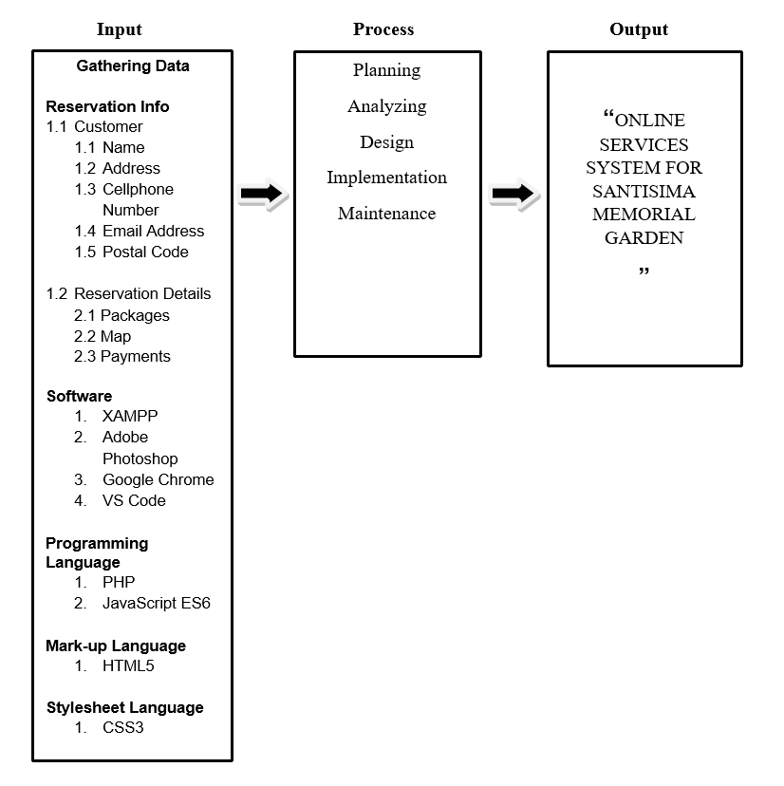*Figure 1. The Conceptual Framework of the developed system*

**Definition of Terms**

To provide an adequate understanding of the various concepts use the terms below are defined conceptually and operationally.

**Browse –**Conceptually, to look through (a book, articles for sale in a shop, etc.) in a casual leisurely manner. (“The free dictionary,”n.d)

Operationally,to look for information on the Internet.

**Browser –**Conceptually, it is a program that accesses and displays files and other data available on the internet and other networks. (“The free dictionary,”n.d)

Operationally, it is a piece of software that allows a user to move around and look at pages on the internet.

**Client**– Conceptually, it refers to a person or organization using the services of a professional person or company. (“Merriam-Webster Dictionary”,n.d)

Operationally, it refers to individuals interested to buy products and services of a company.

**E-commerce** – Conceptually, is a company trading its products or services using computer networks, such as the Internet. (“Merriam-Webster dictionary,” n.d)

Operationally, it refers to the proposed website that is being developed for the Santisima Memorial Garden.

**Online –**Conceptually, connected to a central computer or to a computer network. (“The free dictionary,”n.d)

Operationally, directly connected to and controlled by, an electronic computer.

**System –**Conceptually, a network of related computer software, hardware, and data transmission devices. (“The free dictionary,”n.d)

Operationally, an organized and coordinated method; a procedure.

**Technology**– Conceptually, the application of science, especially to industrial or commercial objectives. (“The free dictionary,”n.d)

Operationally, theoretical knowledge of an industry and industrial arts.

**Transaction–**Conceptually, it is an agreement between a buyer and a seller to exchange an asset for payment. (“InvestorWords”,n.d).

Operationally, it is a time when a buyer and a seller decided on purchasing goods or products.

**User-Friendly –**Conceptually, easily operated and understood by means of a straightforward guide in jargon-free language. (“The free dictionary,”n.d)

Operationally, easy to understand and operate.

**Packages** – Conceptually, it refers to the process of designing, evaluating, and producing a compact product. It also refers to a set of proposals or terms offered or agreed as a whole.

Operationally, it refers to the memorial plan or product of the Online service website for Santisima Memorial Garden. It basically arranged according to process, offer and location.

**Plugins –** Conceptually,is a piece of software that acts as an add-on to a web browser and gives the browser additional functionality.

Operationally, is a code transformed to a file that used in Online Service Website for Santisima Memorial Garden where it gives additional functionality that helps the proposed website run efficiently.

**Database –** Conceptually,it is used to store a data of a website or system.

Operationally, it is the MySQL in XAMPP that serves as the Database of the proposed website thus the file was in SQL format.

**Programming Language –** Conceptually, it composes of codes that can command, instruct and have a different syntax to create a software program.

Operationally, it refers to the front end and back end language used in the proposed website. It is being used to run and implement the Online Services Website for Santisima Memorial Garden.

**CHAPTER III**

**METHODOLOGY**

This chapter covers the Project Planning Procedure, Feasibility Analysis Procedure, System Analysis and Design Procedure, System Development Procedure, Development Tools, and the Testing Evaluation Procedure. This includes all the approaches and actions the developers accomplished in further completing the developed system.

**Software Life Cycle Model**

**Waterfall**

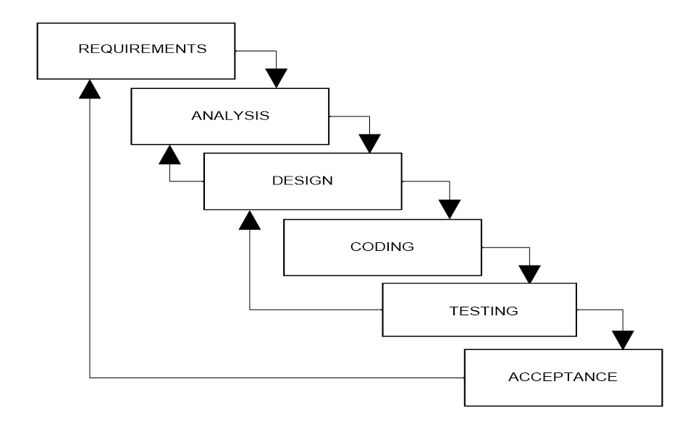

*Figure 2. The Waterfall/ software life cycle model*

**Development Phase**

The information to analyzed and initial design is forwarded to this phase, create which is the working part of the system through coding, and create databases, hardware construction, and overall system development.

After coding and development, the system is being tested and checked for any errors. Especially the administrator and the customer accounts are run for this purpose.

**Testing Phase**

This stage or phase refers to the testing stage of the system where defects are identified, reported, fired and retested, until if achieves the quality standard required.

**Maintenance Phase**

The system requires maintenance and support. In this phase, comments and suggestions made by the customers and administrators of the system are considered for its enhancement. For this purpose, maintenance of the system is scheduled every five months in order to maintain system’s functionality and its updating.

**Project Research Design**

Shows the structure of requirements, processes and outputs that summarizes the ideas of the developed system.

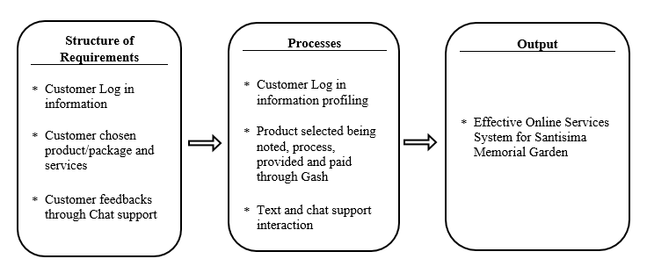

The researcher used developmental research design. It is the systematic study of designing, developing, and evaluating instructional programs, processes, and products that must meet criteria of internal consistency and effectiveness.

**Admin**

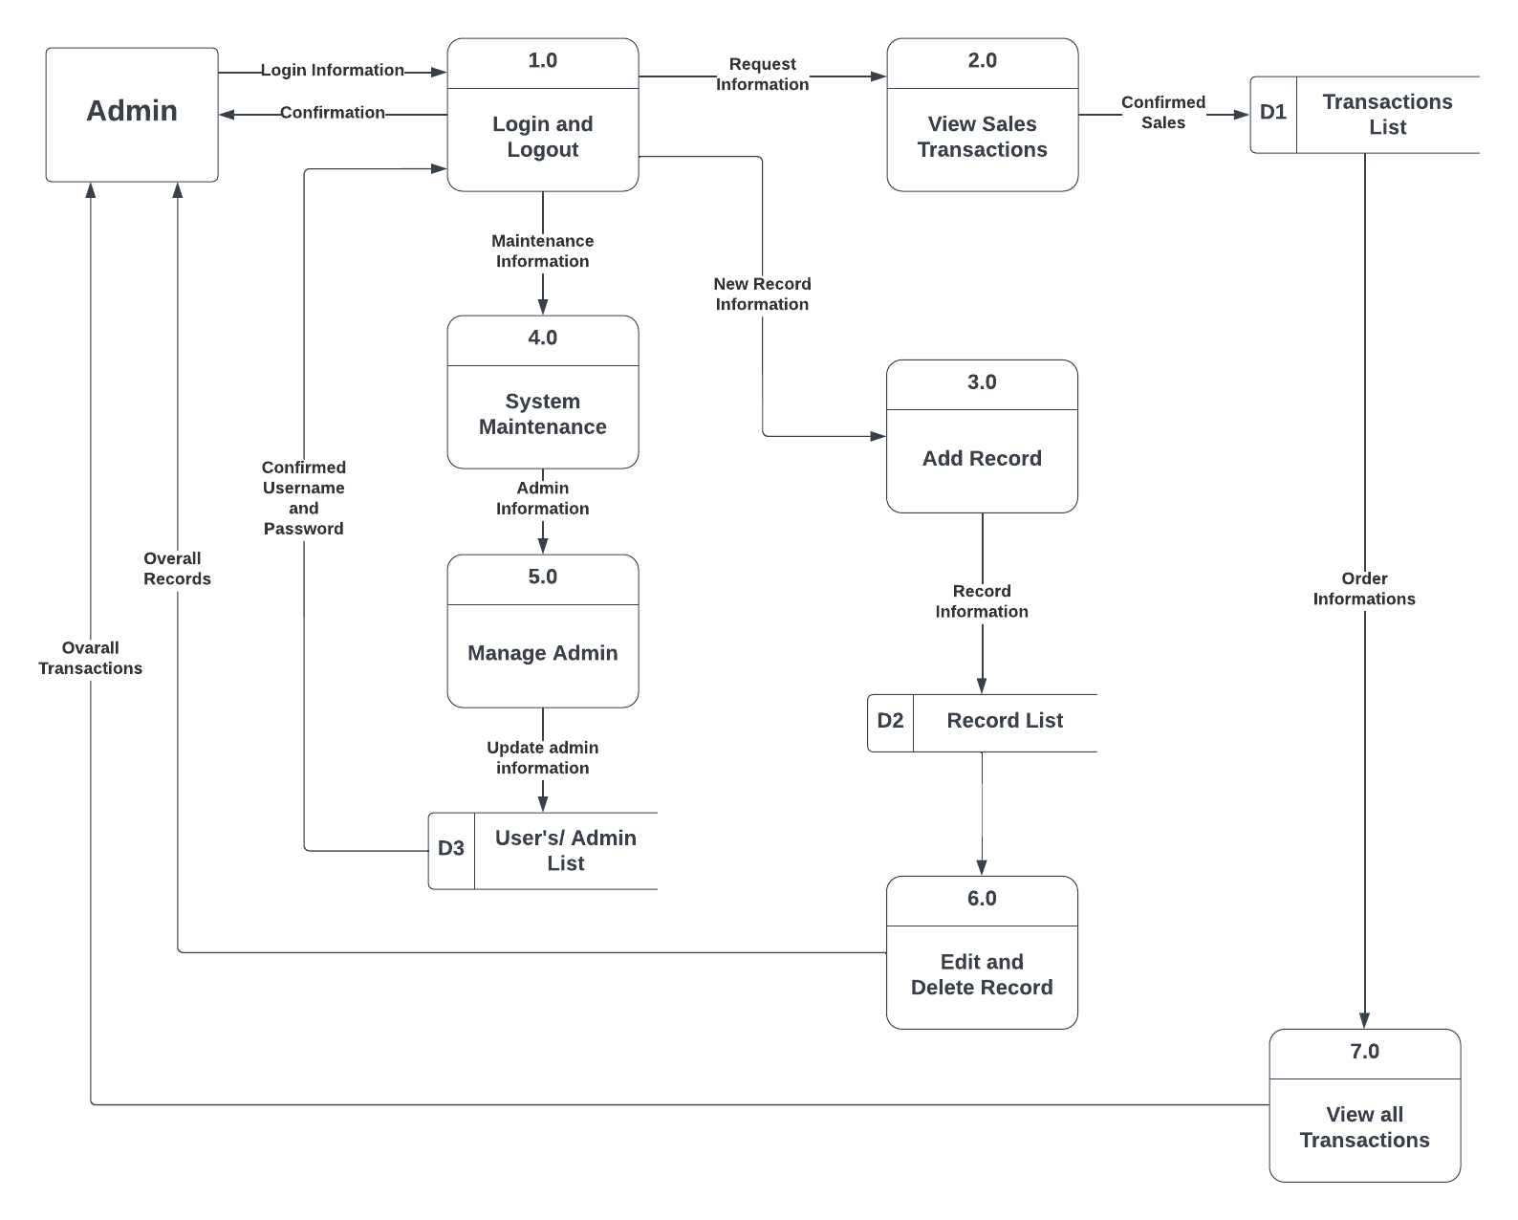

*Figure 3. The Admin side of the Project Research Design*

**User Side**

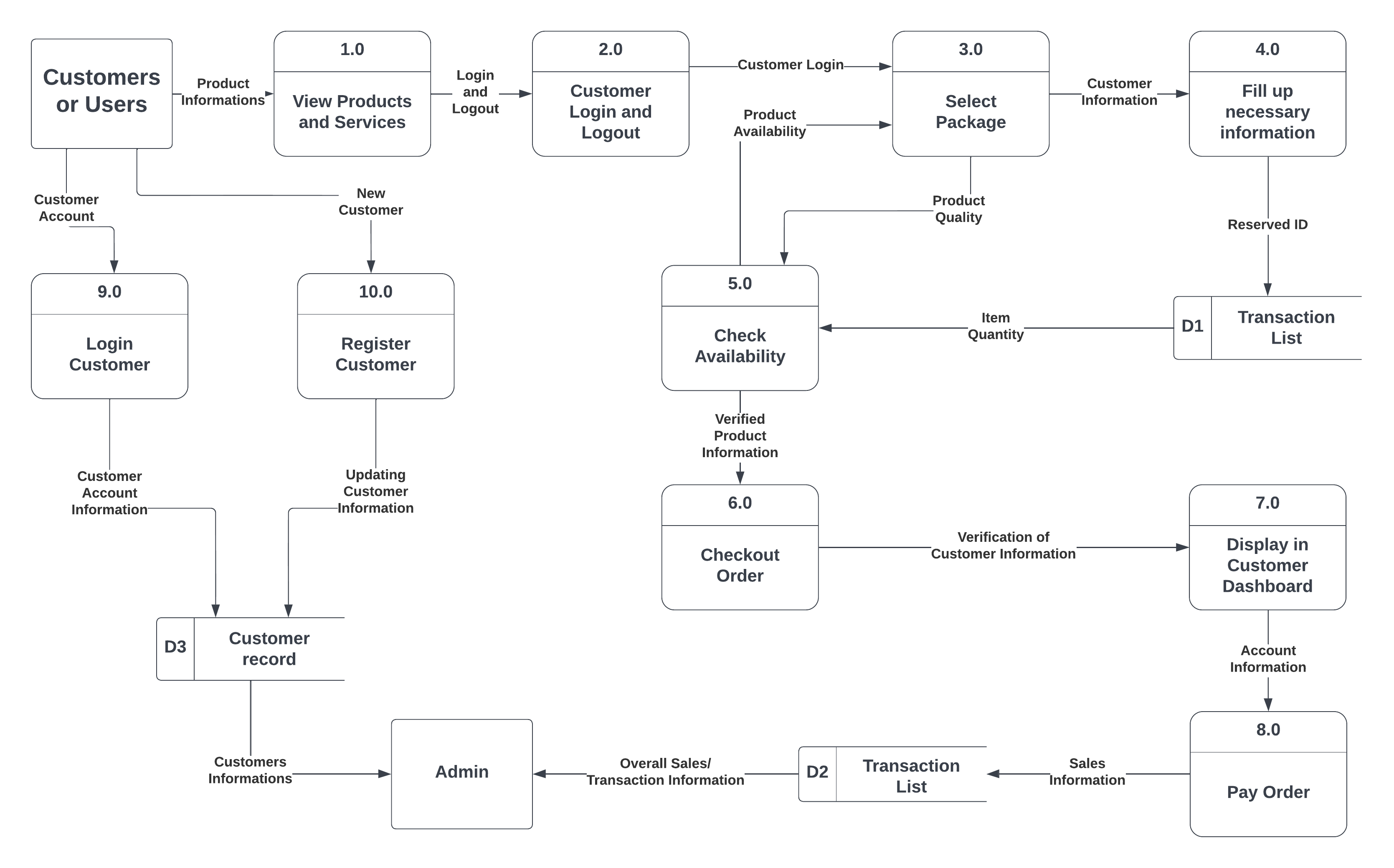

*Figure 4. The user side of the Project Research Design*

**Requirement Specifications**

**Operational Feasibility**

The goals of this system study are to develop the following functionalities:

* An online web-based application that can be accessed anywhere through an internet connection.
* Provide an organized system which allows the company to monitor their income.
* Generate monthly and yearly sales reports.
* View products and services of the companies.
* Program Environment
* Front End and Back End

CSS or Cascading Style Sheets was first developed in 1997 as a way for web developers to define the look and feel of their web pages. It was intended to allow developers to separate content from design so that HTML could perform more of the function that it was originally based on the markup of content, without worry about the design and layout. This programming language will be responsible for placing the data being uploaded to the website in their proper places.

Bootstrap is the most popular HTML, CSS, and JS framework for developing responsive, mobile first projects on the web. Bootstrapping usually refers to the starting of a self-sustaining process that is supposed to proceed without external input.

HTML or HyperText Markup Language is the standard markup language used to create web pages. XHTML or Extensible HyperText Markup Language is a family of XML markup languages that mirror or extend versions of the widely used HTML, the language in which Web pages are written. These are the programming languages that are going to be used for the development of the front end of the system.

**Back End**

PHP is a server-side scripting language designed for web development but also used as a general-purpose programming language. PHP code can be simply mixed with. HTML code or it can be used in combination with various emplacing engines and web frameworks. The PHP code is usually processed by a PHP interpreter, which is usually implemented as a web server native module or Common Gateway Interface (CGI) executable.

MySQL is the most popular database system used with PHP. MySQL is a database system used on the web. It is a database system that runs on a server. It is ideal for both small and large applications. MySQL is very fast, reliable, and easy to use. It supports standard SQL. It compiles on a number of platforms, it is also free to download and use. MySQL is developed, distributed, and supported by Oracle Corporation.

**Technical Feasibility**

Hardware specification (maximum requirement)

**Client**

* Dual-Core Processor
* 1 GB Ram
* 256 Video Card
* Android 4.2 version up to latest version
* Server
* Quad Core Processor
* 4GB Ram (Internal Memory)
* 500GB Hard Drive
* 4GB Video Card
* Software specifications (maximum requirement)

**Client**

* Google Chrome Version 6.3.2
* Mozilla Firefox 17.6
* Windows Operating System

**Server**

* XAMPP

**Software**

**XAMPP**

Database is defined as organized collection of data or information. Database can easily modify its content by deleting, adding, or editing the database content (St. Luke’s School Library). XAMPP is use for database content of websites. It is an open-source package that is widely used for PHP development (Virginia). It is a free and open-source cross-platform web server solution stack package developed by Apache Friends, consisting mainly of the Apache HTTP Server, MariaDB database, and interpreters for scripts written in the PHP and Perl programming languages. (Wikipedia)

**Adobe Photoshop**

According to University of Washington, Adobe Photoshop is the preponderantly photo editing and manipulation software on the market. Its uses range from the featured-filled editing of massive batches of photos to creating complex digital paintings and drawings that mimic those done by hand. While American Graphic Institute explained that it is a software application for image editing and photo retouching for use on Windows or MacOS computers. Photoshop offers users the ability to create, enhance, or edit images, artwork, and illustrations. It is the most widely used software tool for photo editing, image manipulation, and retouching for numerous image and video file formats.

**Google Chrome**

Madalina Dinita (2020) said that Google Chromeis one of the best browsers for editing WordPress with the majority of the market share running into hundreds of millions. Chrome offers WordPress users fast performance and the ability to utilize unlimited resources for WordPress editing. Google Chrome makes it possible to install add-ons and Chrome extensions to make the website developer’s job easier. A WordPress user can install additional plug-ins needed for editing WordPress to enjoy maximum efficiency.

**VS Code**

It is a streamlined code editor with support for development operations like debugging, task running, and version control. It aims to provide just the tools a developer needs for a quick code-build-debug cycle and leaves more complex workflows to fuller featured IDEs, such as Visual Studio IDE.

**Programming Languages**

**PHP**

PHP stands for Hypertext Preprocessor. It is an open source, server-side, scripting language used for the development of web applications. By scripting language, we mean a program that is script-based written for the automation of tasks. Web pages can be designed using HTML. With HTML, code execution is done on the user's browser. On the other hand, with PHP server-side scripting language, it's executed on the server before it gets to the web browser of the user. It can be embedded in HTML, and it's well suited for web development and the creation of dynamic web pages for web applications, e-commerce applications, and database applications. It's considered a friendly language with abilities to easily connect with MySQL, Oracle, and other databases. (study.com)

**JavaScript ES6**

JavaScript ES6 (also known as ECMAScript 2015 or ECMAScript 6) is the newer version of JavaScript that was introduced in 2015. ECMAScript is the standard that JavaScript programming language uses. ECMAScript provides the specification on how JavaScript programming language should work.

**Mark-up Language**

**HTML5**

Is a [markup language](https://en.wikipedia.org/wiki/Markup_language) used for structuring and presenting content on the [World Wide Web](https://en.wikipedia.org/wiki/World_Wide_Web). It is the fifth and final major [HTML](https://en.wikipedia.org/wiki/HTML) version that is a [World Wide Web Consortium](https://en.wikipedia.org/wiki/World_Wide_Web_Consortium) (W3C) recommendation. The current specification is known as the [HTML Living Standard](https://en.wikipedia.org/wiki/HTML_Living_Standard). It is maintained by the [Web Hypertext Application Technology Working Group](https://en.wikipedia.org/wiki/Web_Hypertext_Application_Technology_Working_Group) (WHATWG), a consortium of the major browser vendors ([Apple](https://en.wikipedia.org/wiki/Apple_Inc.), [Google](https://en.wikipedia.org/wiki/Google), [Mozilla](https://en.wikipedia.org/wiki/Mozilla), and [Microsoft](https://en.wikipedia.org/wiki/Microsoft)).

**Stylesheet Language**

**CSS3**

CSS3 is used with HTML to create and format content structure. It is responsible for colours, font properties, text alignments, background images, graphics, tables, etc. It provides the positioning of various elements with the values being fixed, absolute, and relative. To help build highly interactive online pages, CSS3 is highly commended as it provides wider options for designing. When advertising products and services, the website is first viewed by a customer, it should be appealing and attractive, and this can be achieved with the help of CSS3. CSS3 allows the designer to create websites, rich in content and low in code. This technology brings some exciting features that make the page look good, simple for the user to navigate, and functions flawlessly.

**FLOW CHART**

Figure 5 shows the flowchart of the Online Services Website for Santisima Memorial Garden. It shows the picture of separate steps of a process in sequential order. Flowchart is a common process analysis tool.

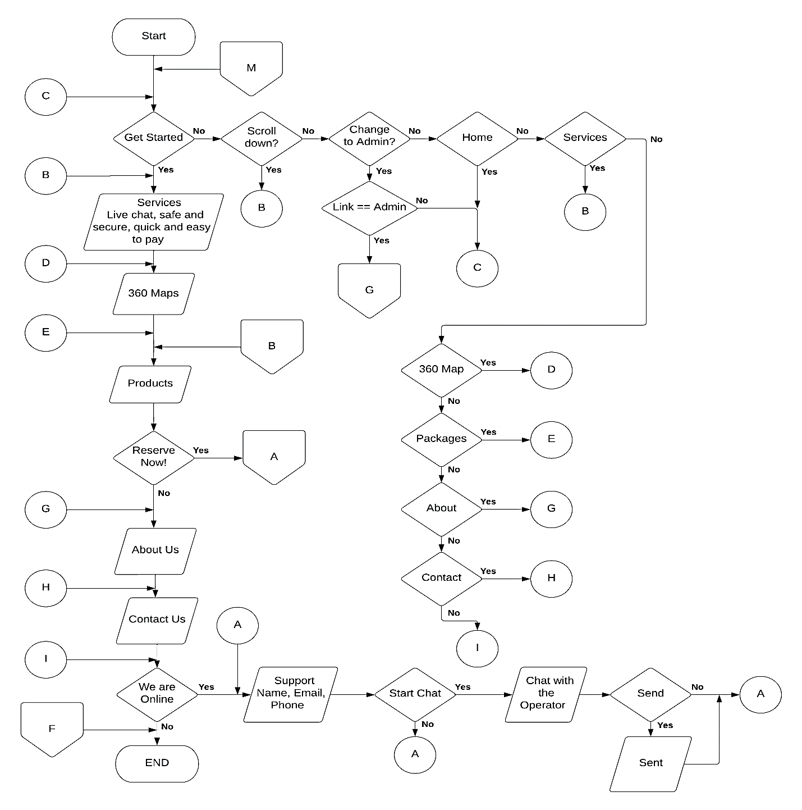

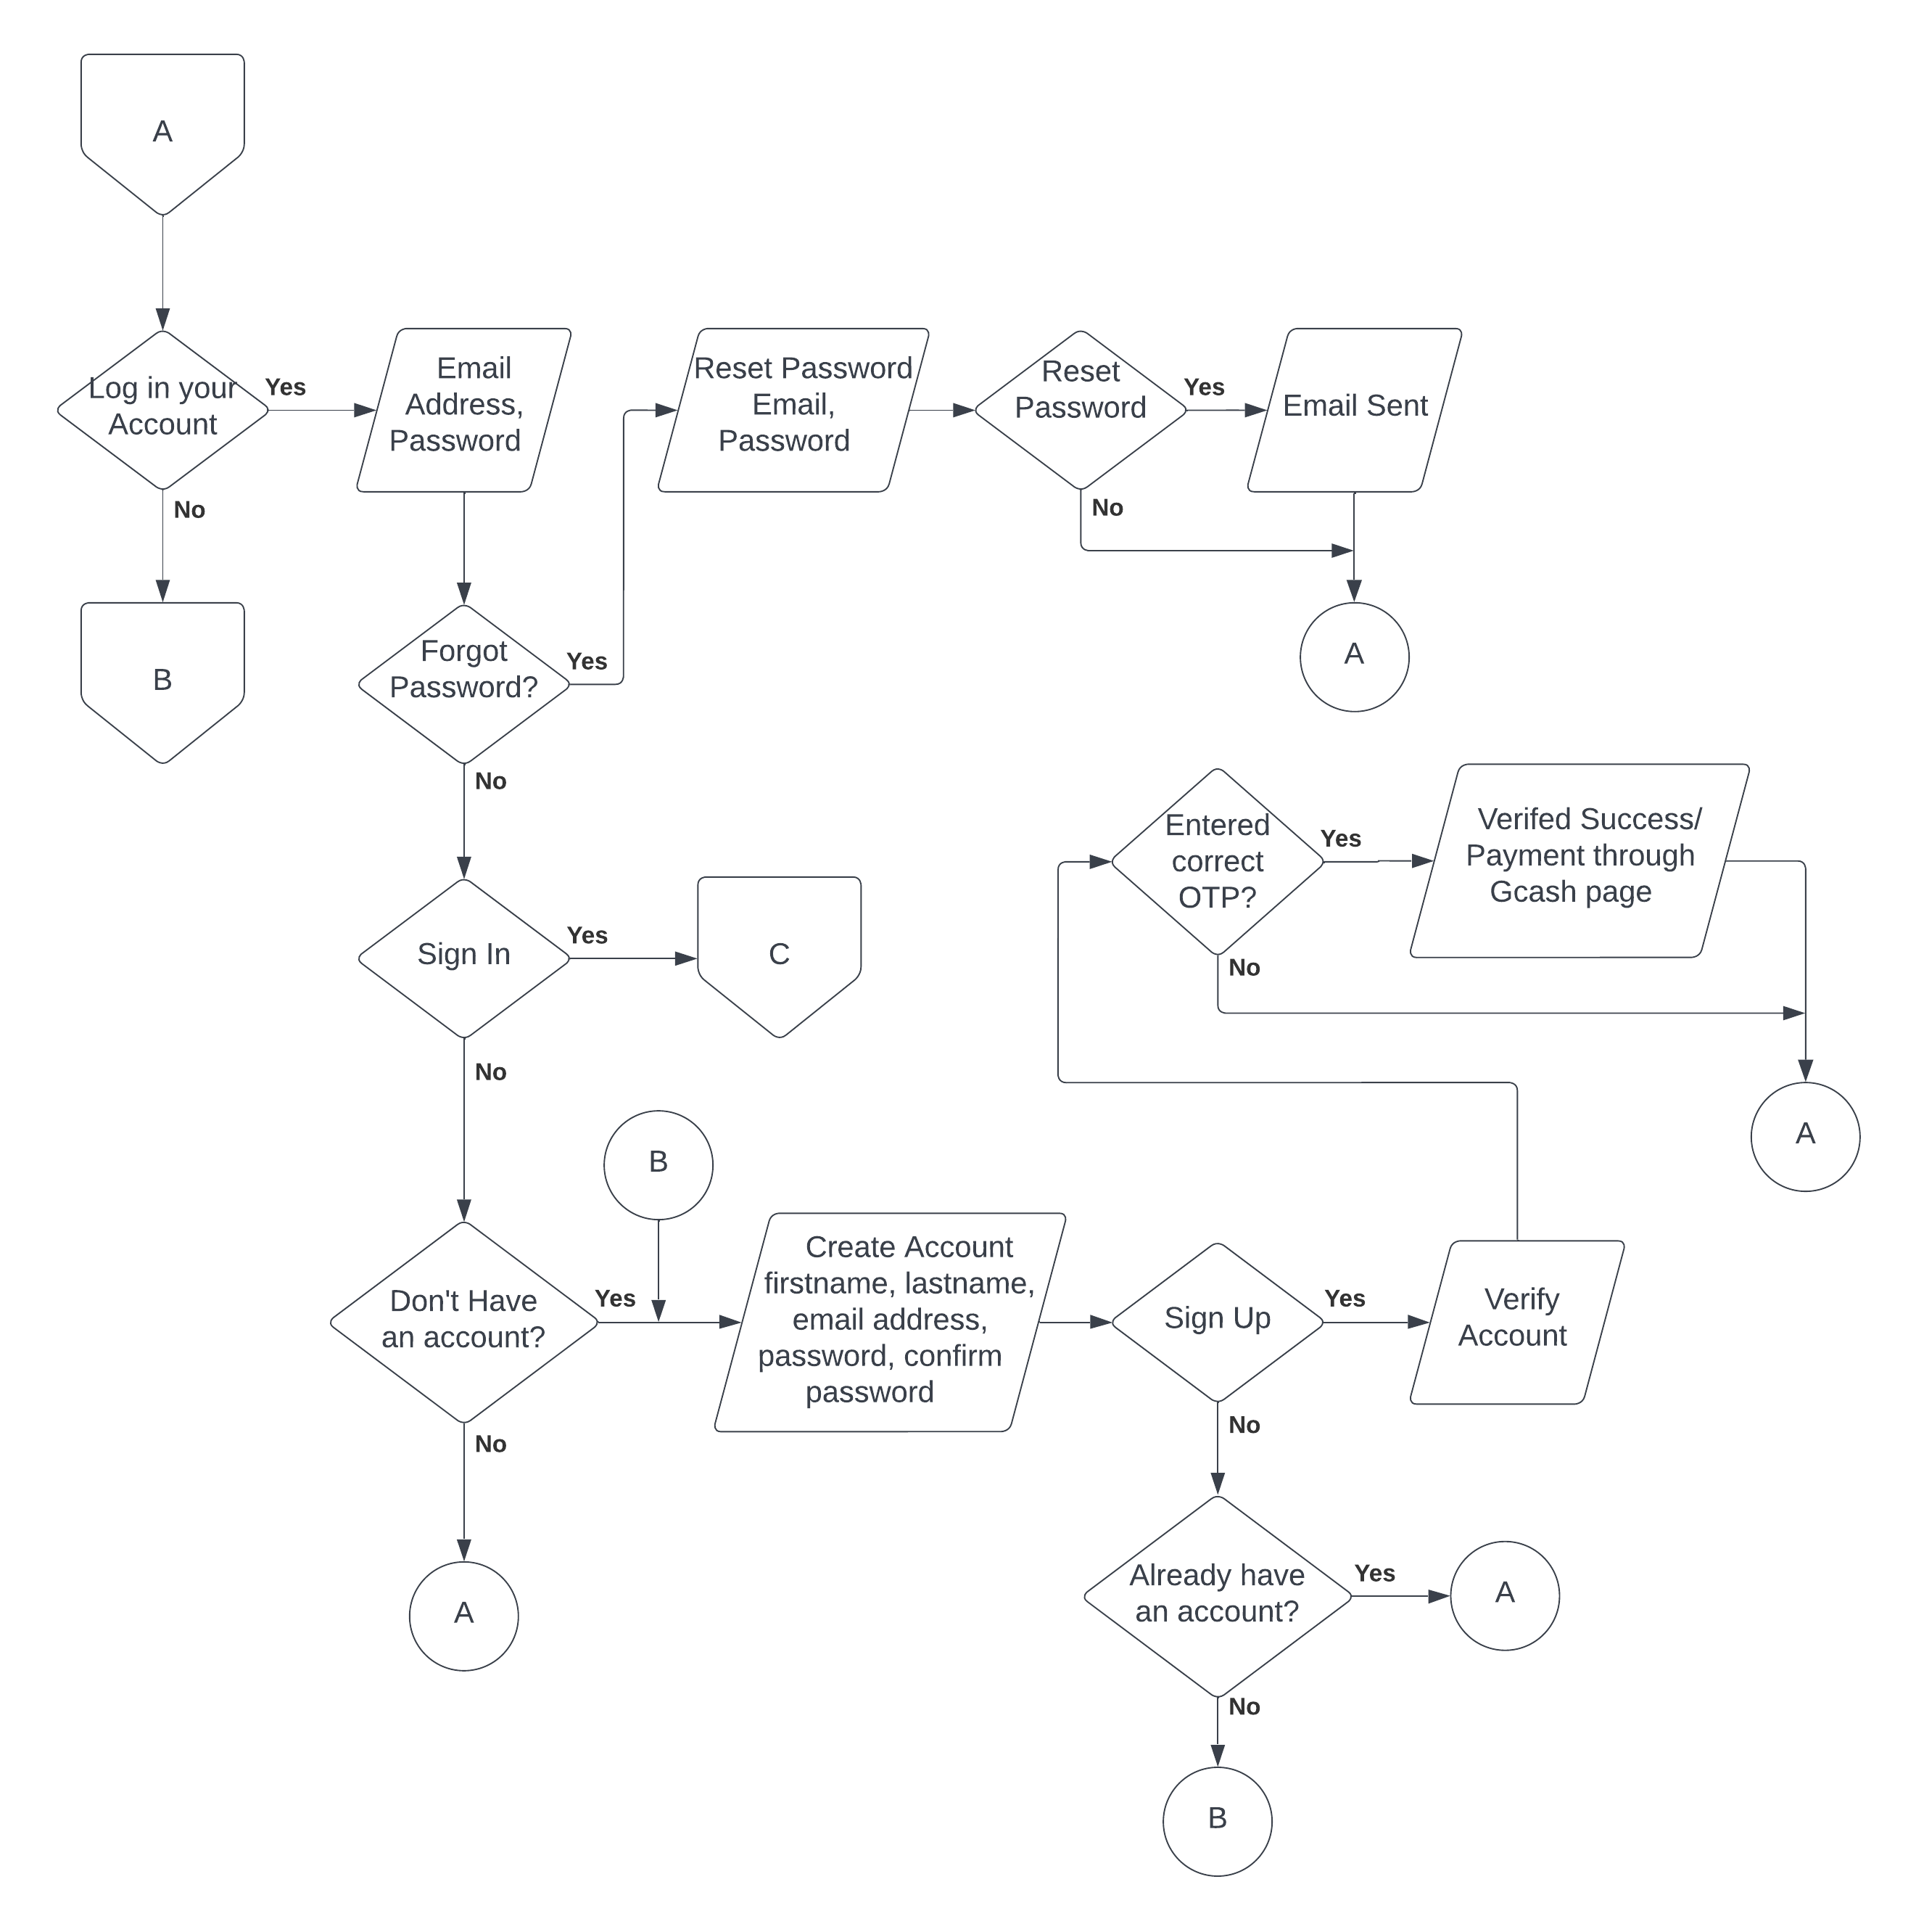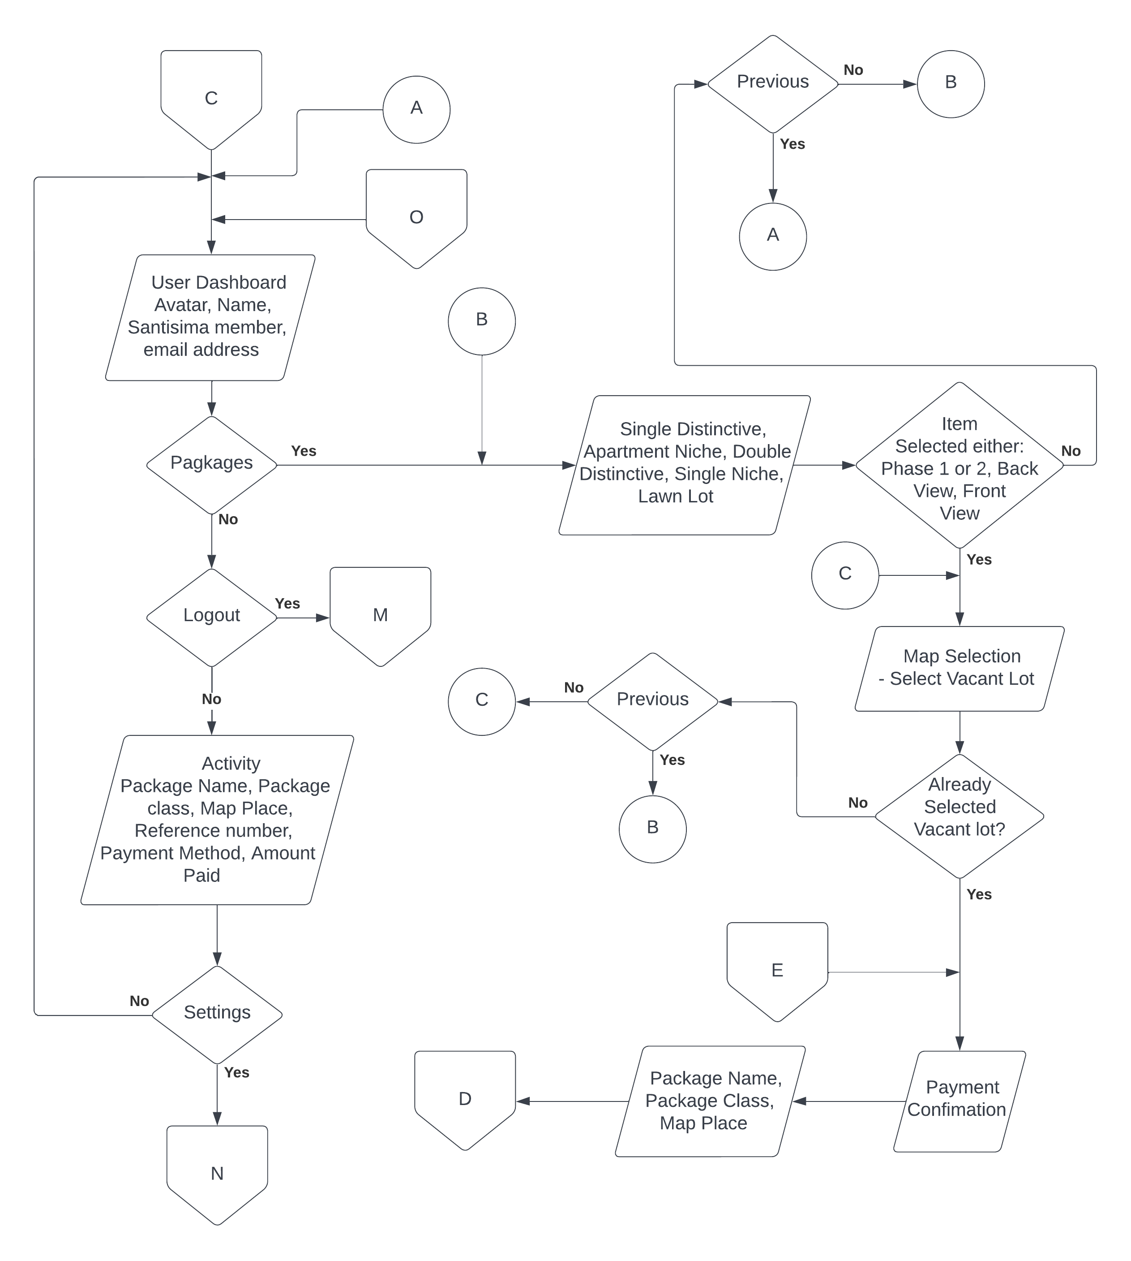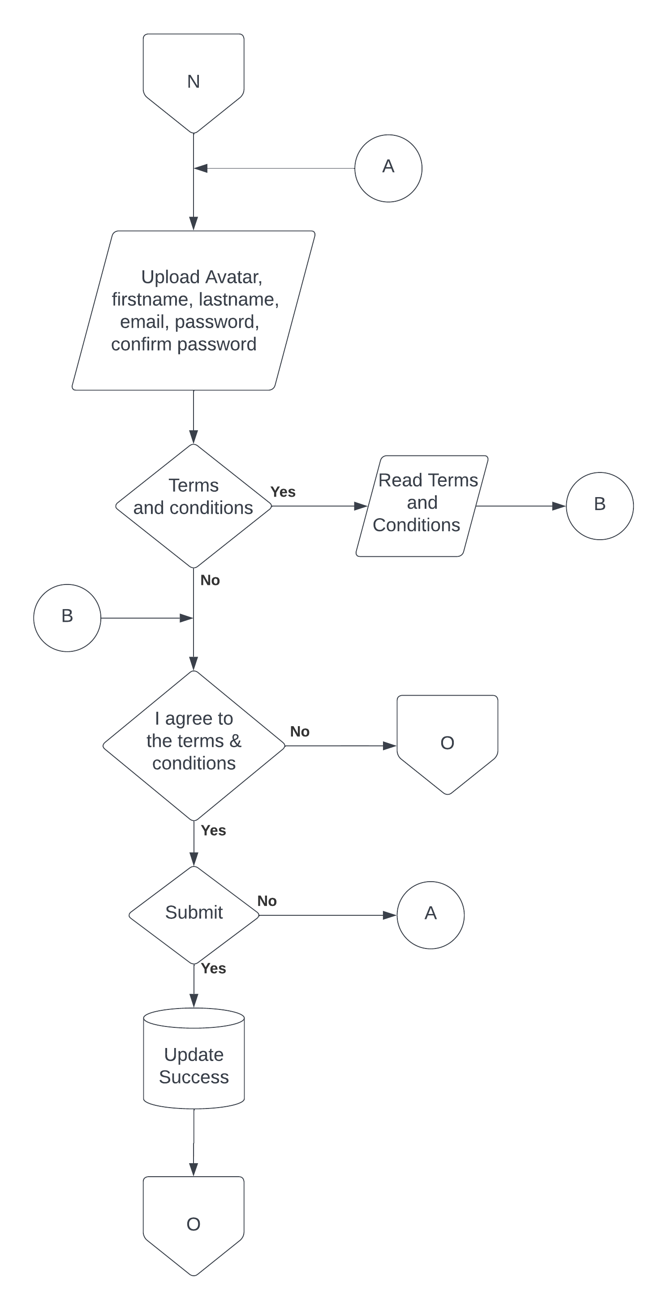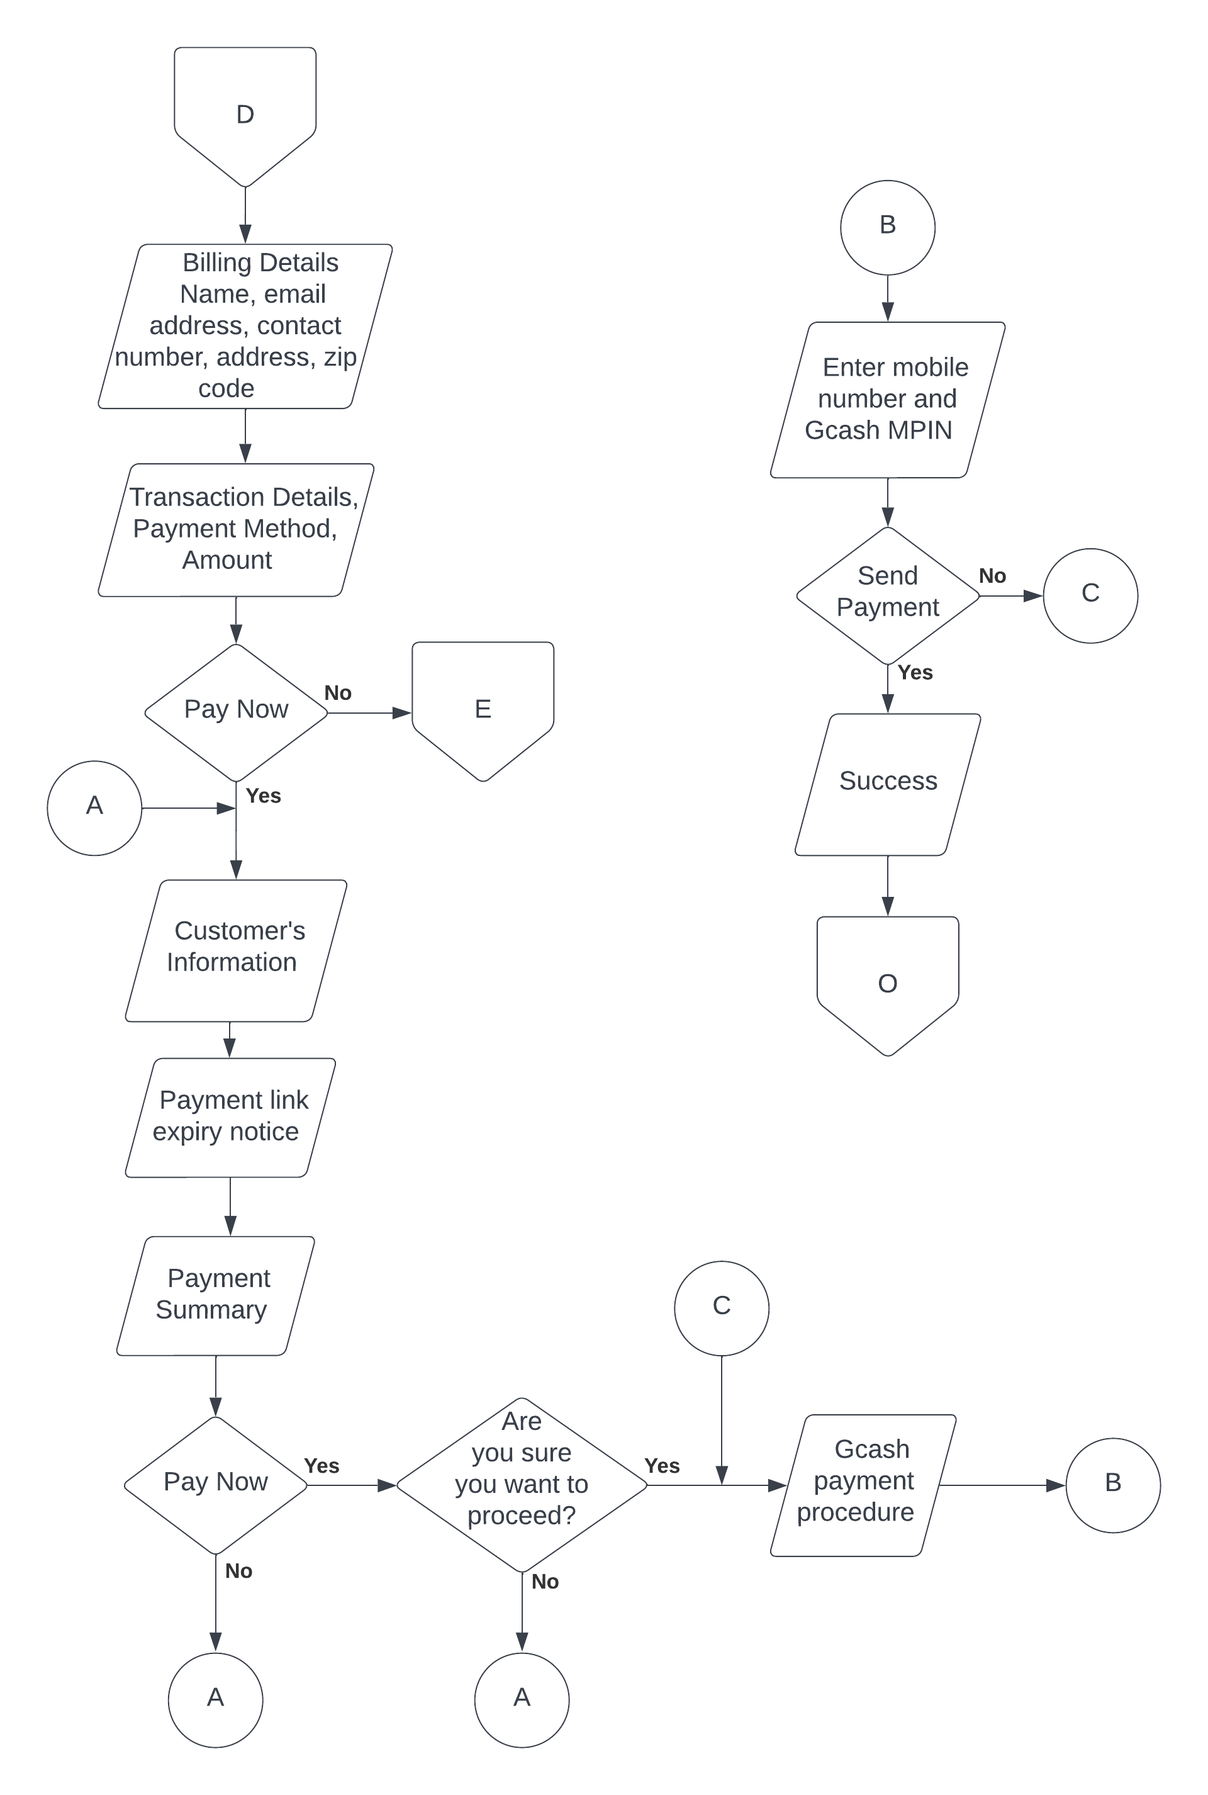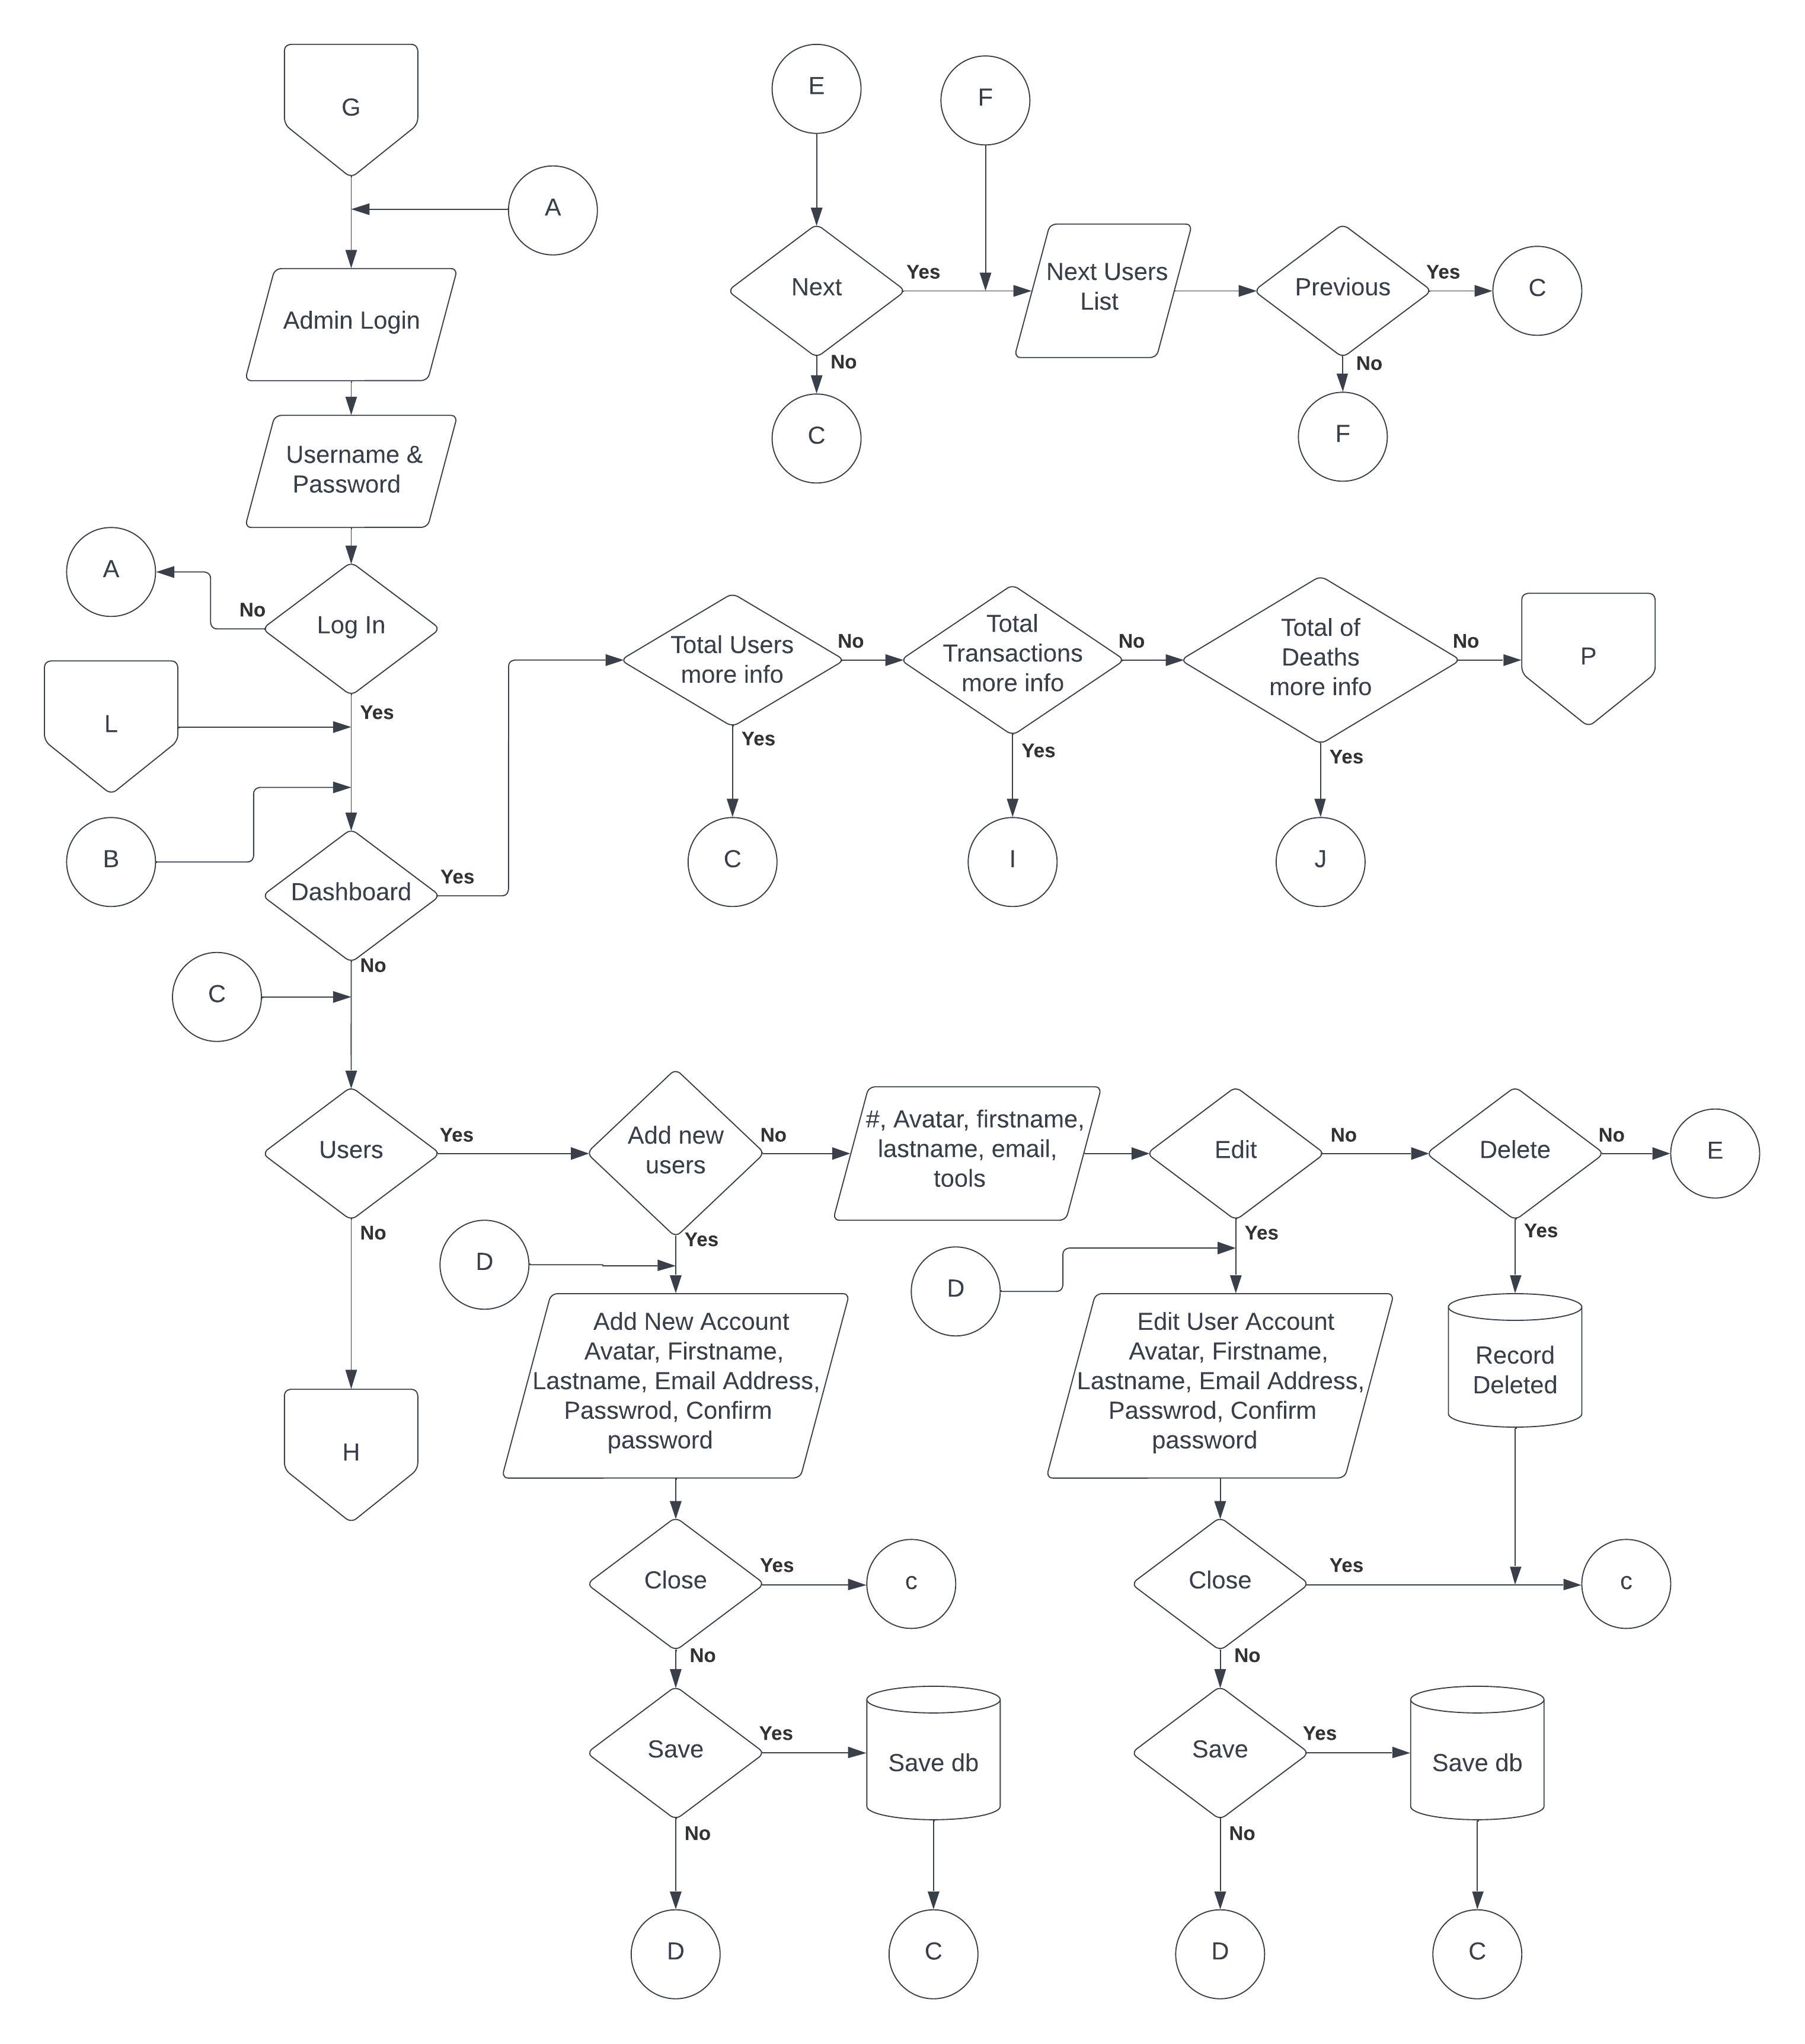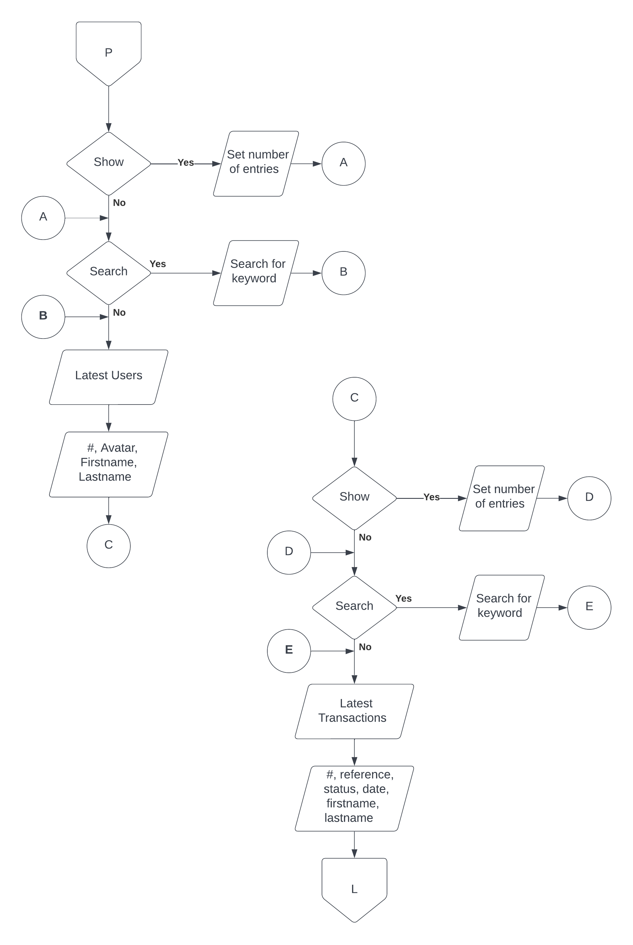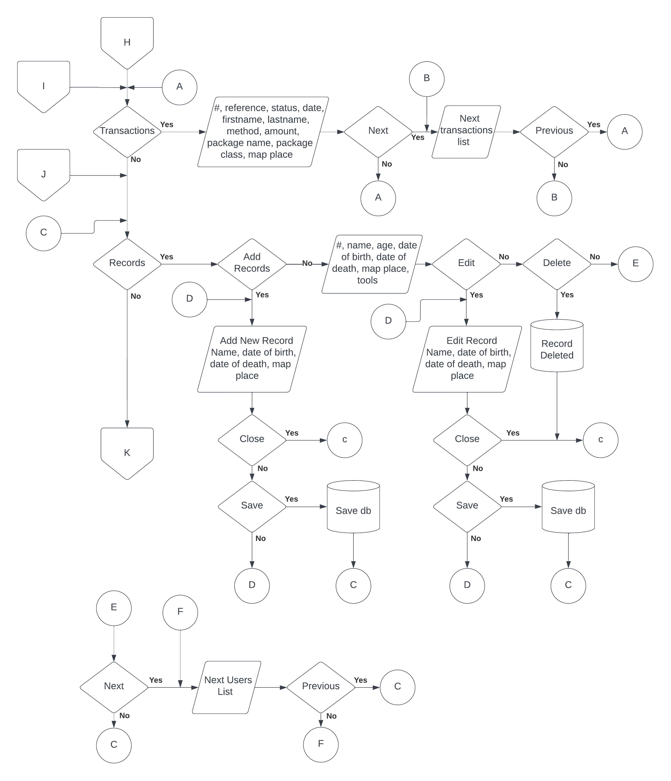

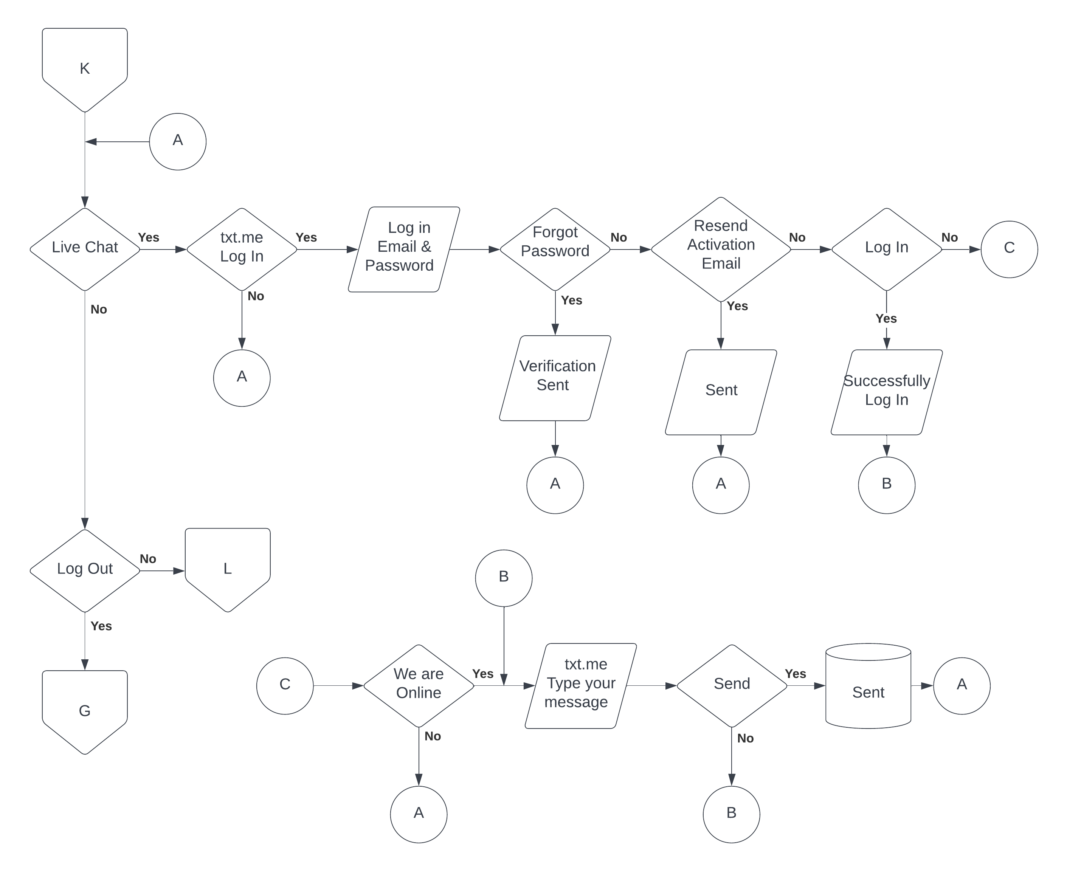

*Figure 5. System Flowchart of the Online Services Website for Santisima Memorial Garden*

**Budget Proposal**

This expenses are required in order for the system to implement and to make it work. Both the hardware and software expenses are all listed.

**Table 1: Budget Proposal Expenses**

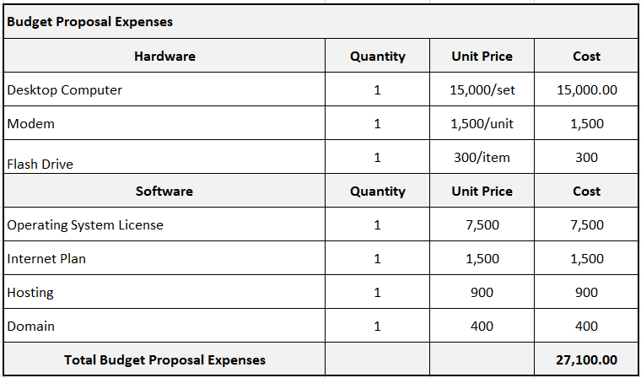

**Cost Benefits Analysis**

**Table 2: Developmental Cost**

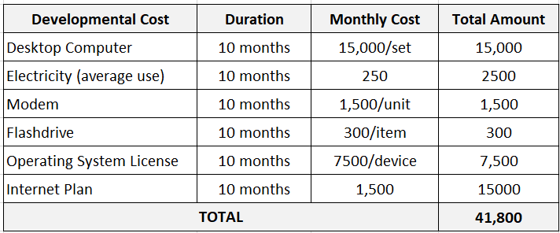

This table shows the developmental cost of the system. The developmental cost includes the above-detailed costs relating human power utility expenses.

**Table 3: Operational Cost**

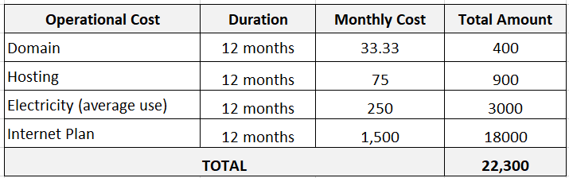

**Table 4: Total Developmental and Operational Cost**

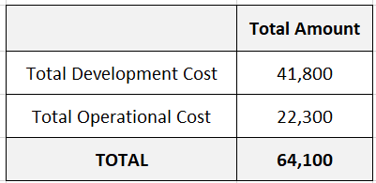

This table sums up the total cost of the development and operation of the system.

**Table 5: Benefits of the System**

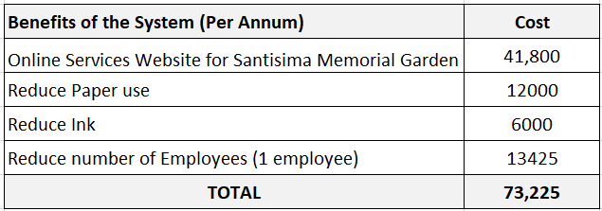

**CHAPTER IV**

**Project Technical Description**

The system was developed by utilizing the following software and hardware resources:

**Software Requirements**

* Program Development Tools
* VScode
* Adobe Photoshop
* XAMPP (php & mysql)
* Core FTP
* Operating System
* Windows 10
* Web Browser
* Google Chrome/ mozilla firefox

**Hardware Requirements**

* Mouse (PS2 or USB port)
* QWERTY Keyboard (PS2 or USB port)
* LED Monitor
* System Unit or Laptop

**PROJECT STRUCTURED ORGANIZATION**

This section shows the screenshots of every webpage of the proposed website. The functions and features are shown and discussed.

The following are the screenshot of the user side or the customer side of the proposed website. It will be followed by the admin side.

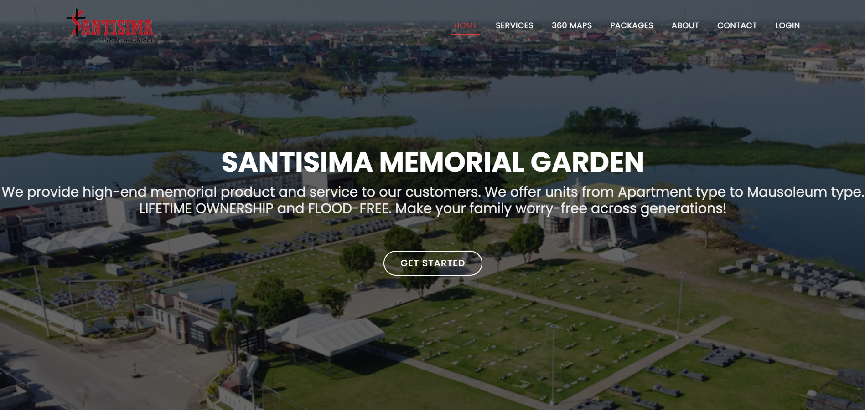*Figure 6. Homepage of Online Services for Santisima Memorial**Garden*

This page act as the landing page of the website

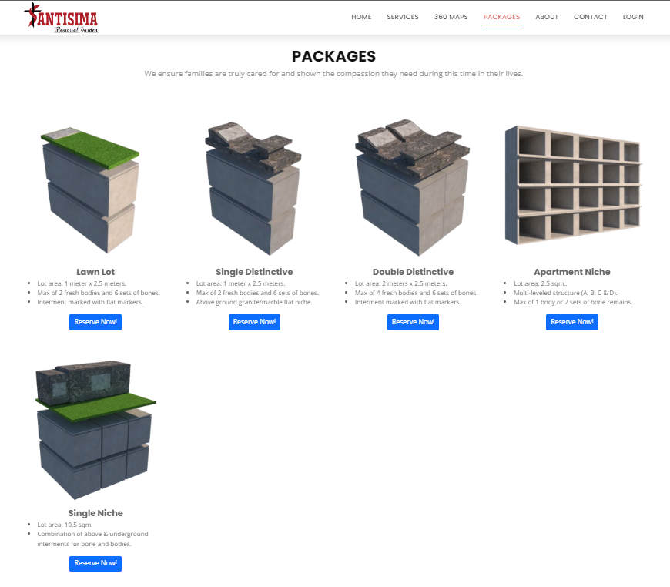

*Figure 7. Product and services page of Online Services for Santisima Memorial**Garden*

This page shows the product and services at santisima memorial garden

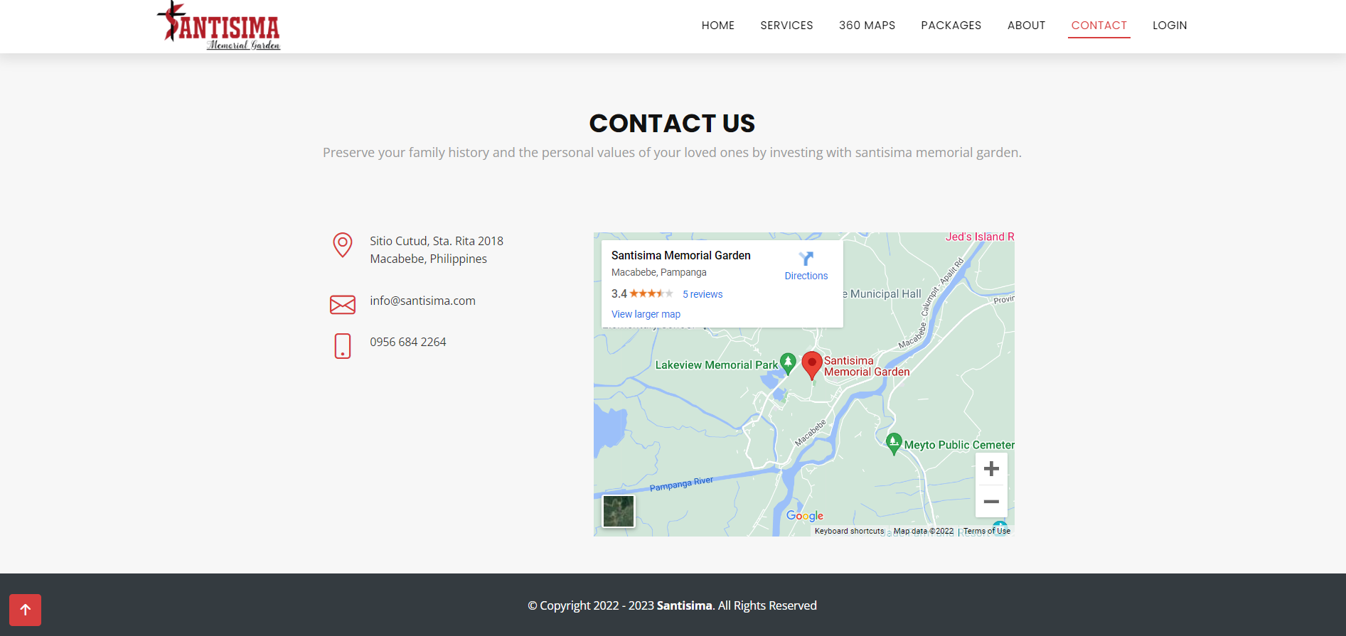

*Figure 8. contacts page of Online Services for Santisima Memorial**Garden*

This page provides a contact information of the memorial such as phone number, email address and location of the memorial. It provides also a contact form for the other concern.

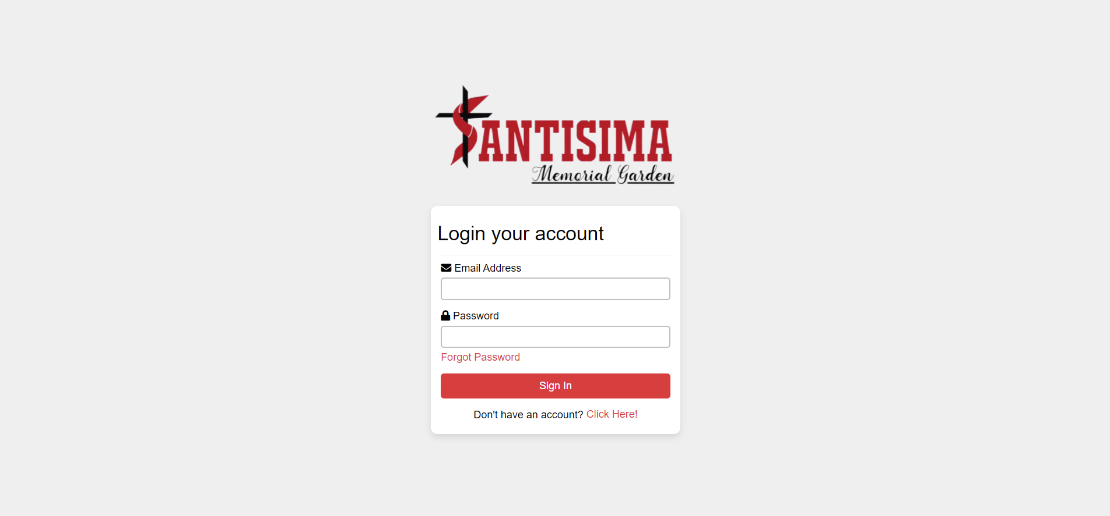

*Figure 9. login page of Online Services for Santisima Memorial**Garden*

This page shows the log in form. The correct Log in information are necessary in order for the user to enter respective accounts.

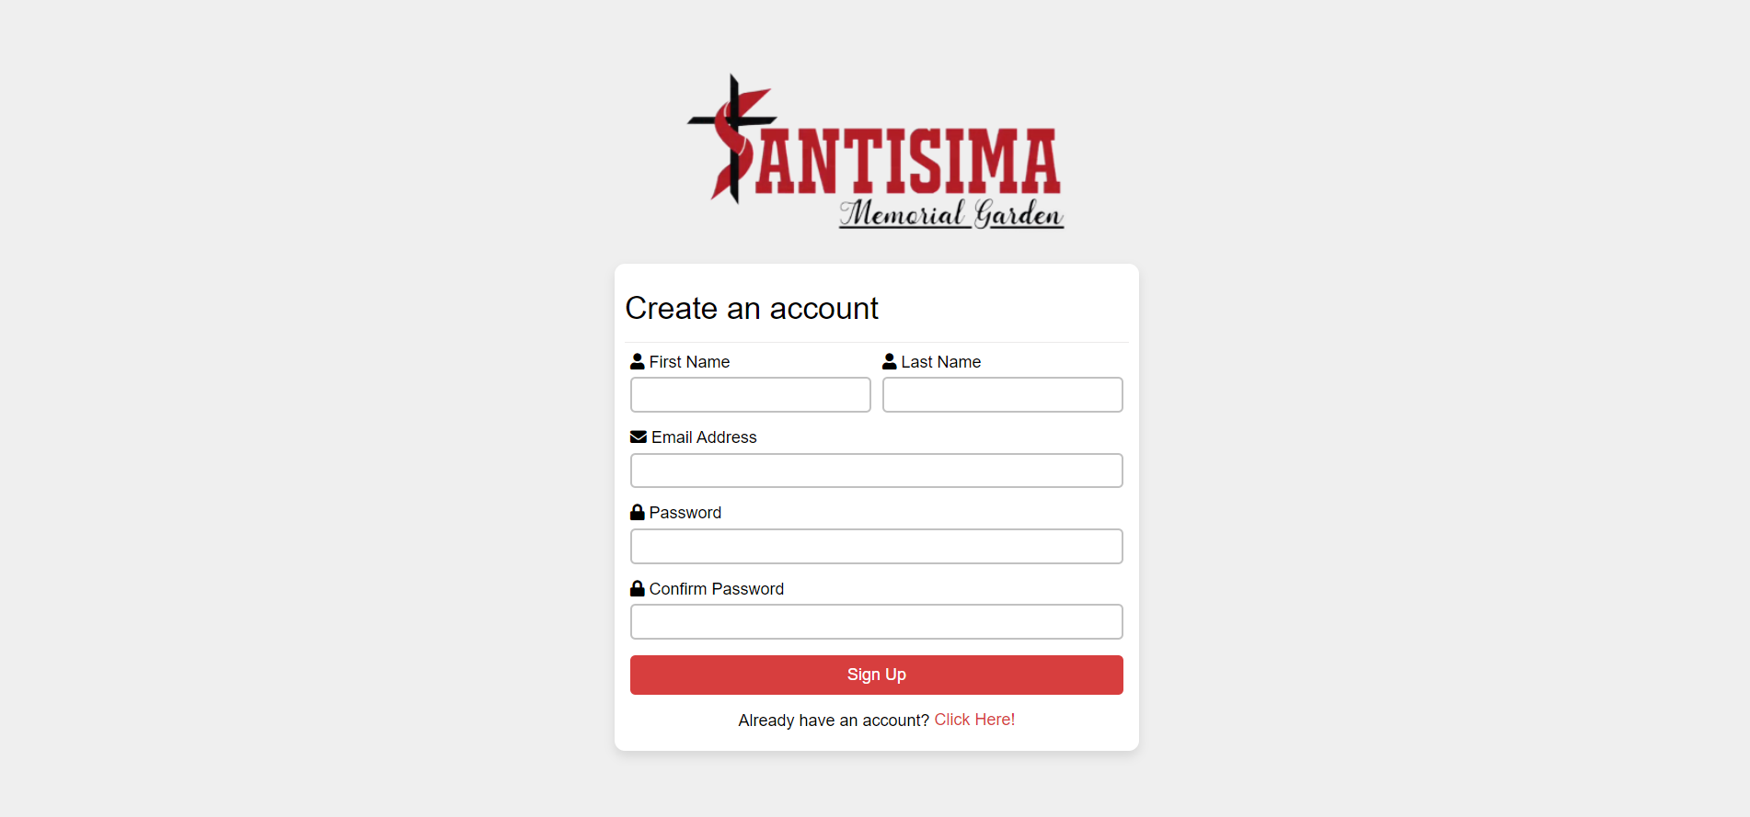

*Figure 10. Sign up page of Online Services for Santisima Memorial**Garden*

This page shows the sign up form. To create an account, the user must register his/her first name, last name, email address and password.

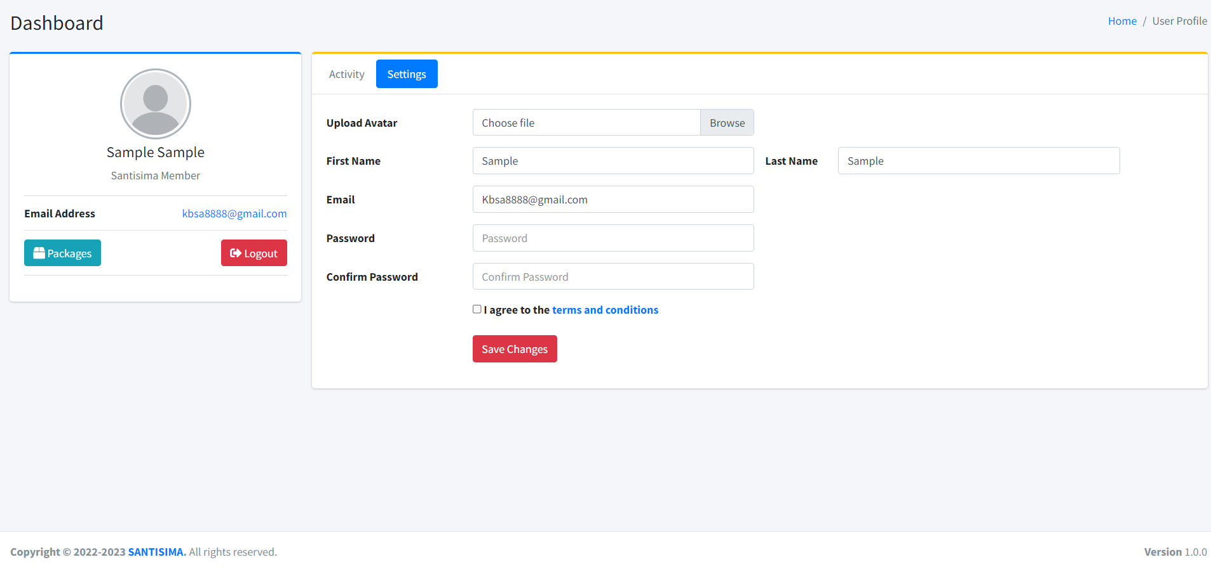

*Figure 11. customer information page of Online Services for Santisima Memorial**Garden*

This page where you can fill-up a form for about customer personal information

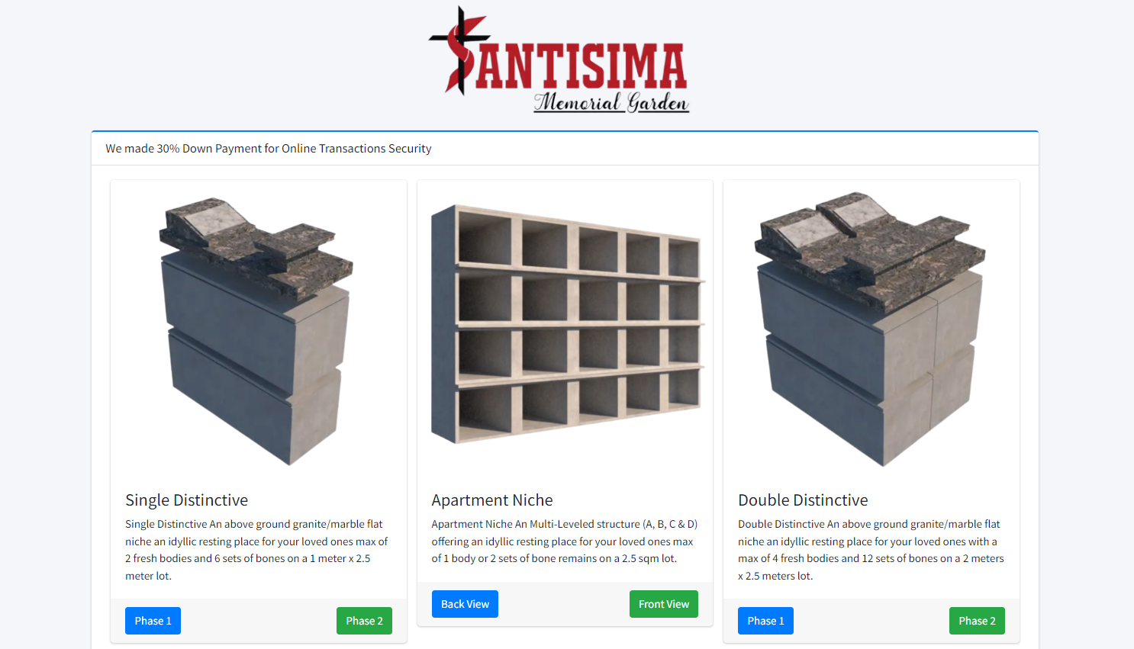

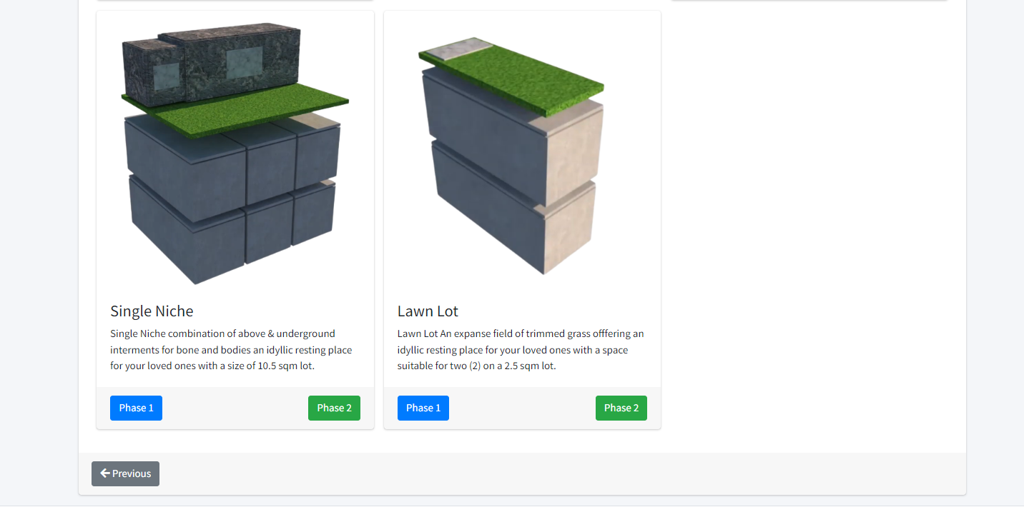

*Figure 12. Product conformation reservation page of Online Services for Santisima Memorial**Garden*

This page shows the location of product if phase 1 or phase 2

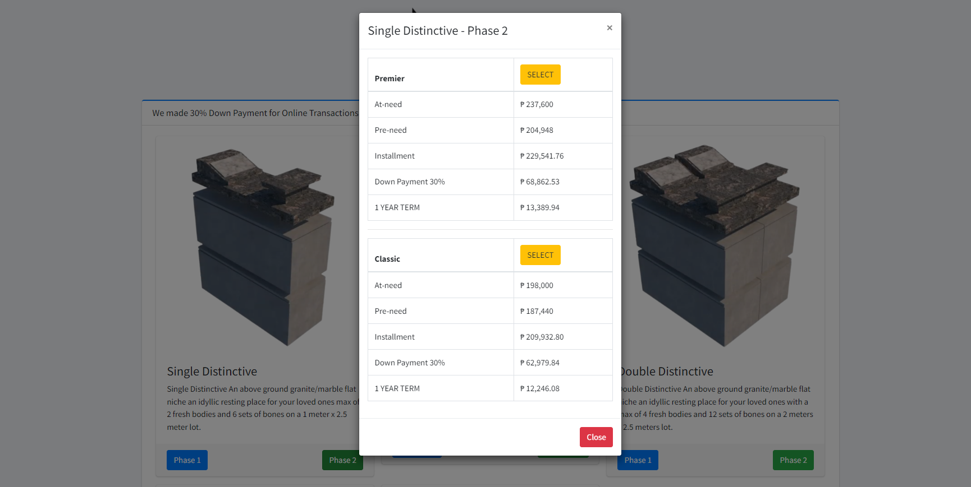

*Figure 13. Product conformation reservation page of Online Services for Santisima Memorial**Garden*

This page shows the prices and payment.

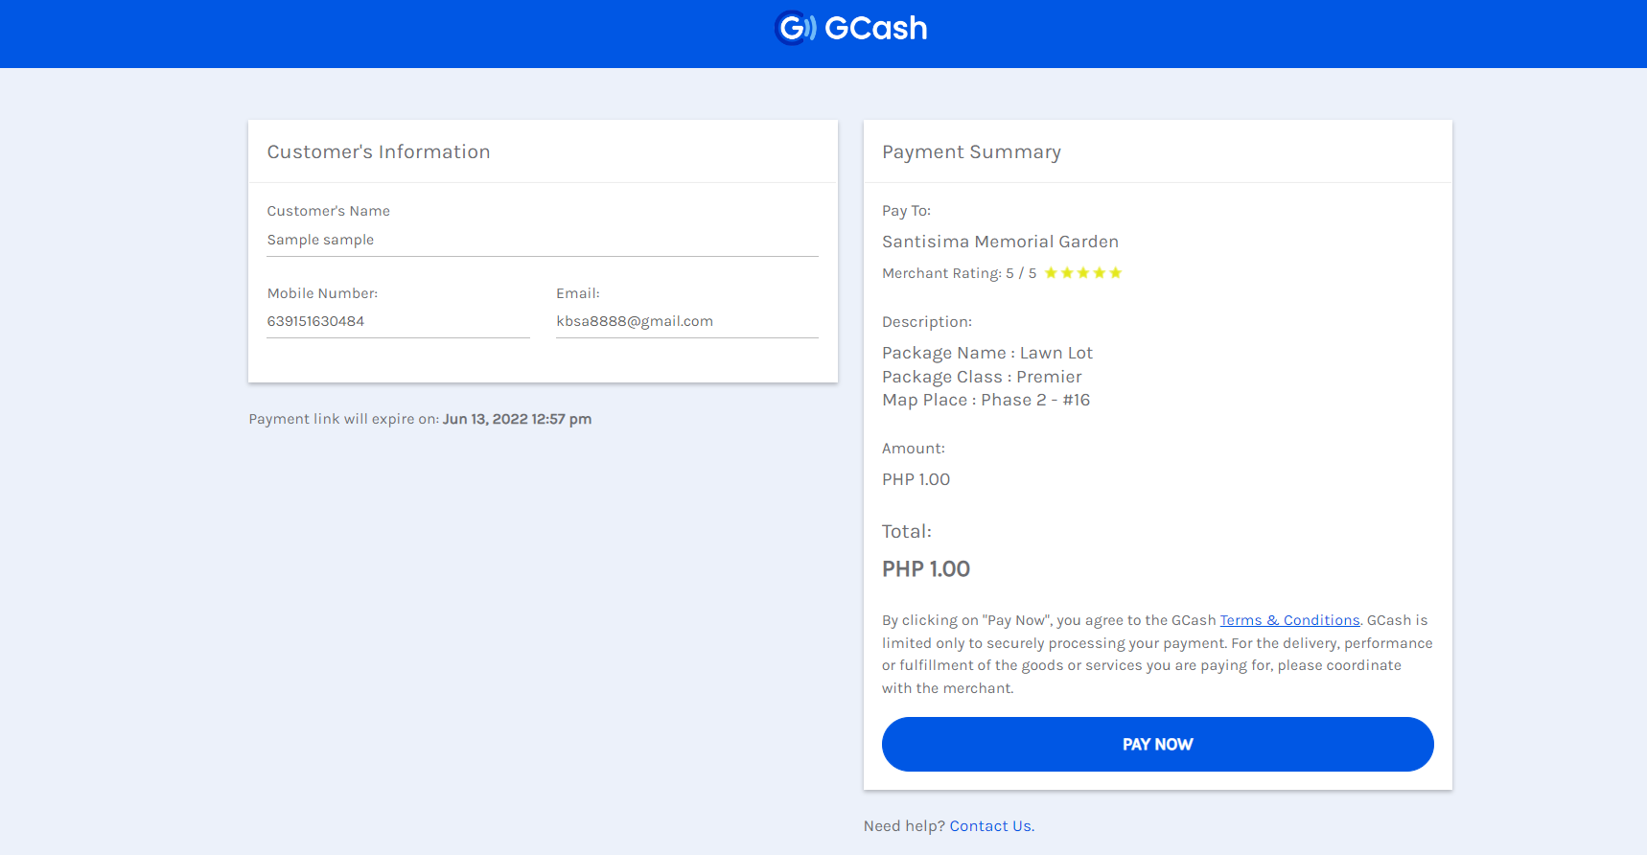

*Figure 14. Payment summary page of Online Services for Santisima Memorial**Garden*

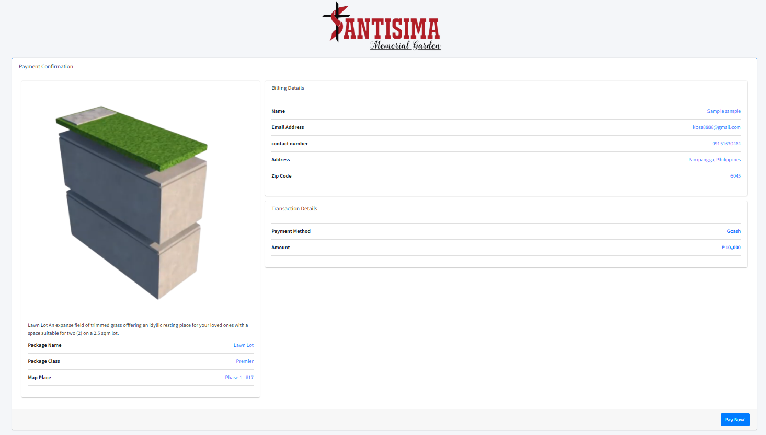

*Figure 15. Summary of selected unit and payment method page of Online Services for Santisima Memorial**Garden*

The following screenshots are the admin side of the proposed website. It shows the dashboard, users, transactions, records and the live chat.

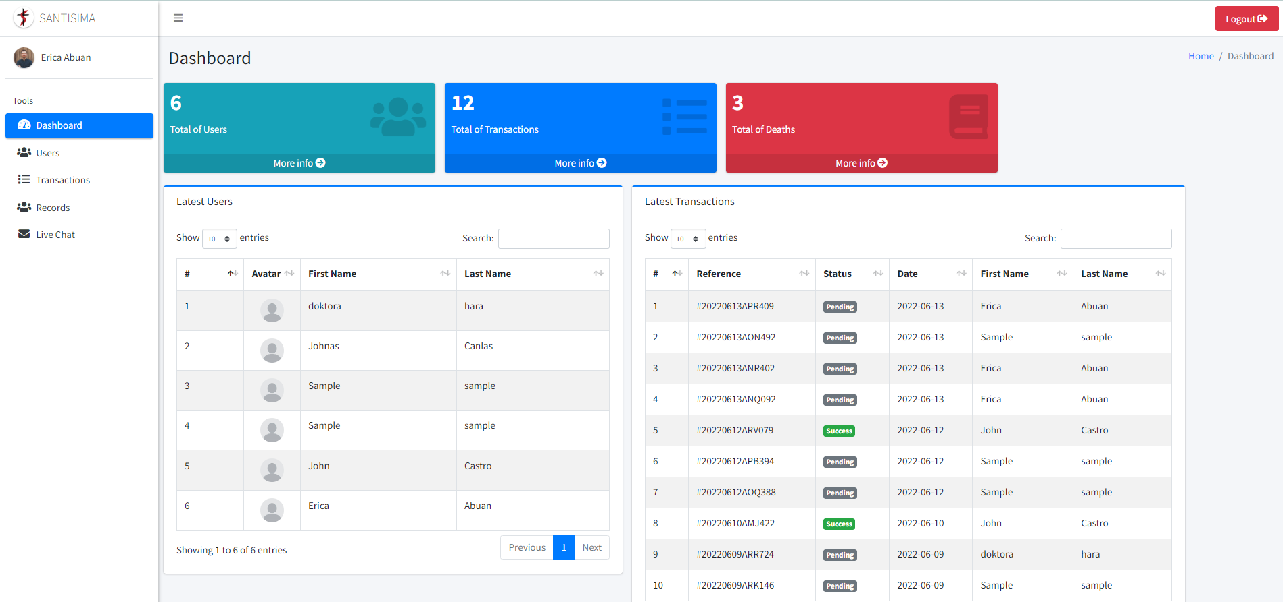

*Figure 16. Dashboard of the website in the admin side of the website*

The figure 16 shows the dashboard of the proposed website. It shows the data of the website like the total users, transactions and deaths. Moreover, it shows the table of the latest users and latest transactions.

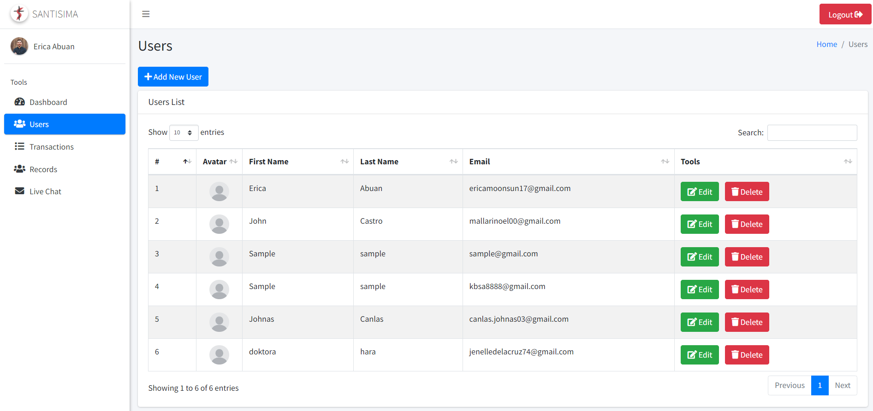

*Figure 17. Users list or the registered number of customers to the website*

Figure 17 shows the users list where the table is available having the field names of #, avatar, first name, last name, email and tools.

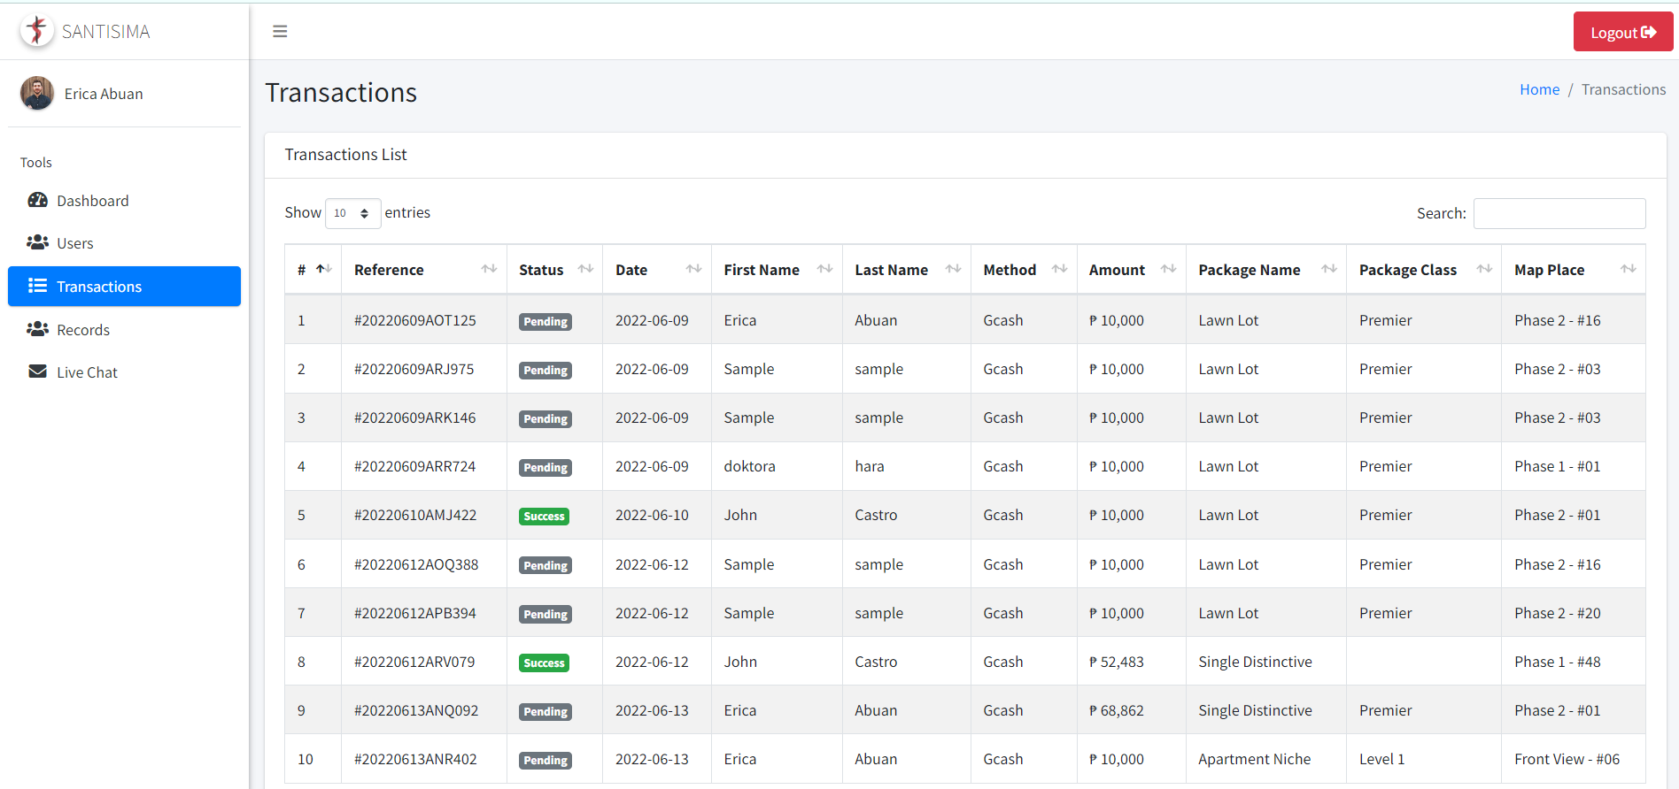

*Figure 18. Transactions list of the Online Services Website for Santisima Memorial Garden*

The Figure 18 shows the transactions list of the Online Services Website for Santisima Memorial Garden. It shows the payment reference number, name of the customer, payment method, amount being paid, package name, package class and the map place.

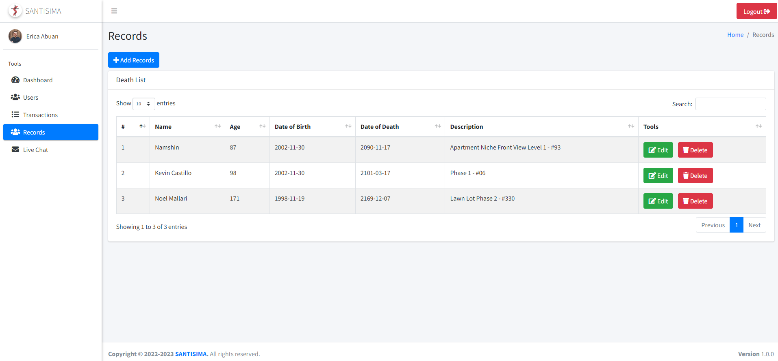

*Figure 19. Records list of the website*

The Figure 19 shows the list of record of the Online Services Website for Santisima Memorial Garden.

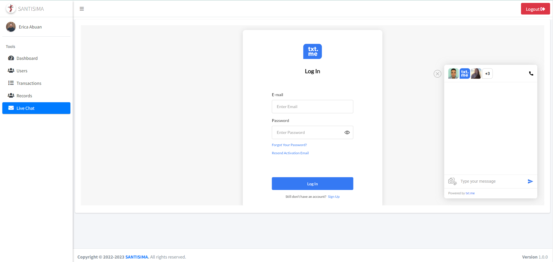

*Figure 20. Live chat support of the proposed website*

Figure 20 shows the chat support of the proposed website. This will become useful for the customer and business interaction.

**PROJECT LIMITATION AND CAPABILITIES**

The proposed system has limitations. The system only allows the registered customer to check and view the product and services using their account or given ID or username and password. The payment mode is only available for online payment the system will also cover some aspects that can be viewed only by the admins and the website will notify the users if they entered the invalid information

**PROJECT EVALUATION**

**Table 6:** Project Evaluation result in terms of Functionality of the system

|  |  |  |  |  |  |  |  |
| --- | --- | --- | --- | --- | --- | --- | --- |
|  | **FREQUENCY** | | | | | | |
| 1. **FUNCTIONALITY** |  | | | | | | |
| **ITEM** | **Excellent**  **(5)** | **Very Good**  **(4)** | **Good**  **(3)** | **Fair**  **(2)** | **Poor**  **(1)** | **Mean** | **Descriptive Interpretation** |
| 1. User- Friendly | 7 | 3 | 0 | 0 | 0 | 4.7 | Strongly Agreed |
| 1. Easy to access | 9 | 1 | 0 | 0 | 0 | 4.9 | Strongly Agreed |
| **Total Mean** | | | | | | **4.8** | **Strongly Agreed** |

**Table 7:** Project Evaluation result in terms of Usability of the system

|  |  |  |  |  |  |  |  |
| --- | --- | --- | --- | --- | --- | --- | --- |
|  | **FREQUENCY** | | | | | | |
| 1. **USABILITY** |  | | | | | | |
| **ITEM** | **Excellent**  **(5)** | **Very Good**  **(4)** | **Good**  **(3)** | **Fair**  **(2)** | **Poor**  **(1)** | **Mean** | **Descriptive Interpretation** |
| 1. Easy to navigate the website | 9 | 1 | 0 | 0 | 0 | 4.9 | Strongly Agreed |
| 1. Easy to understand the online services of Santisima | 9 | 1 | 0 | 0 | 0 | 4.9 | Strongly Agreed |
| **Total Mean** | | | | | | **4.9** | **Strongly Agreed** |

**Table 8:** Project Evaluation result in terms of Reliability of the system

|  |  |  |  |  |  |  |  |
| --- | --- | --- | --- | --- | --- | --- | --- |
|  | **FREQUENCY** | | | | | | |
| 1. **RELIABILITY** |  | | | | | | |
| **ITEM** | **Excellent**  **(5)** | **Very Good**  **(4)** | **Good**  **(3)** | **Fair**  **(2)** | **Poor**  **(1)** | **Mean** | **Descriptive Interpretation** |
| 1. Meet the standards of existing reliability | 9 | 0 | 1 | 0 | 0 | 4.8 | Strongly Agreed |
| 1. Easily restore the data | 6 | 3 | 1 | 0 | 0 | 4.2 | Strongly Agreed |
| **Total Mean** | | | | | | **4.5** | **Agreed** |

**Table 9:** Project Evaluation result in terms of Maintainability of the system

|  |  |  |  |  |  |  |  |
| --- | --- | --- | --- | --- | --- | --- | --- |
|  | **FREQUENCY** | | | | | | |
| 1. **MAINTAINABILITY** |  | | | | | | |
| **ITEM** | **Excellent**  **(5)** | **Very Good**  **(4)** | **Good**  **(3)** | **Fair**  **(2)** | **Poor**  **(1)** | **Mean** | **Descriptive Interpretation** |
| 1. Project modified easily | 7 | 3 | 0 | 0 | 0 | 4.7 | Strongly Agreed |
| 1. System continue functioning if changes are made | 7 | 3 | 0 | 0 | 0 | 4.7 | Strongly Agreed |
| **Total Mean** | | | | | | **4.7** | **Strongly Agreed** |

**Table 10:** Project Evaluation result in terms of Efficiency of the system

|  |  |  |  |  |  |  |  |
| --- | --- | --- | --- | --- | --- | --- | --- |
|  | **FREQUENCY** | | | | | | |
| 1. **Efficiency** |  | | | | | | |
| **ITEM** | **Excellent**  **(5)** | **Very Good**  **(4)** | **Good**  **(3)** | **Fair**  **(2)** | **Poor**  **(1)** | **Mean** | **Descriptive Interpretation** |
| 1. System respond quick | 8 | 2 | 0 | 0 | 0 | 4.8 | Strongly Agreed |
| 1. . Utilize resource efficiency | 8 | 1 | 1 | 0 | 0 | 4.7 | Strongly Agreed |
| **Total Mean** | | | | | | **4.8** | **Strongly Agreed** |

**CHAPTER V**

**SUMMARY**

The goal of this project was to create an online services system to make the reservation easier, faster, and more efficient.

SANTISIMA MEMORIAL GARDEN is a lack of information the previous deal. Many people are dying as a result of the current pandemic, which is why memorial lots are so important to families. The demand for memorial lots is growing, and many people are investing and purchasing them. As a result, Santisima Memorial Garden wishes to develop their own website to better serve their clients in order to solve the above stated problems, the management of the cemetery together with the researchers decides to develop an online services system that will convert manual processes into a database to provide the clients a much better service and to reduce and eliminate the problems caused by a manual processing of transactions. The researchers developed an Online Services System to give clients an easy way to choose the type of lots they want using the website and decide and reserved products or services they want without visiting the site. Santisima Memorial Garden's online services system will be used to develop the company's marketing transactions the system will handle the reserving and marketing of products via the internet.

Data was gathered using the descriptive research approach and the survey technique. A standard questionnaire was used as a data collection method. The survey was performed by the proponents with a focus on adult respondents and the 10 adults who were given the survey. The survey was done after the system had been created and was ready to be developed. Processing of reservation through email can be confusing the system only allows customers who have registered to check and access their accounts by entering their email or login and password. The admin doesn’t have a decent platform for them to easily manage and organize reservation.

The cemetery management as well as customers/clients had access to the system. Customer details must be registered (full name, address, contact, email address). Once the account has been activated, the customer can now login, view the services and product to apply for reservation of niche. The transaction will be verified by management, and the consumer will be notified of the payment process through email. To finalize the transaction, all relevant forms must be submitted. With the simplified process, the management can monitor the payment.

Doing research is an important process that helps us learn about the world around us. It takes a lot of time and effort to find credible sources and to make sure that your information is accurate. By researching different topics, we can gain a better understanding of them and learn new information. You also need to be able to synthesize all of the information you have found into a valid argument. When you perform project, you are essentially trying to solve a problem you want to know how something works or why something happened. In other words, you want to answer a question that you have about. This is one of the most basic reasons for performing research.

**CONCLUSION**

The online services system for Santisima memorial garden is a website which let customers to reserve smoothly. It uses internet connection to access the website and it also provides accurate details about product, services and reservation process.

The reservation for Santisima memorial garden can be a great help on the company to manage and properly assist the clients. It will enhance the speed to process the reservation and make interaction between staff and the clients more convenient.

The researchers therefore conclude that the Online services system for Santisima memorial garden might help its company and employees to operate the business more efficiently.

**RECOMMENDATION**

Based on the findings of this study, the proponents recommend for future researchers to enhance the features of the website. It is recommended to use a mobile application to know your balance and record the monthly payment or to work better and create a mapping to see the product properly and improve the online payment method.

1. Creating user account in the system is recommended in order to use it since all of the data and customer transaction, payables and data will be saved on their respective accounts.

2. Creating Gcash account is required since it is the payment method supported by the system. Furthermore, it is recommended if similar study is conducted, the researcher must add new payment method.

3. It is recommended if similar study is being conducted, creating mobile application will be great help.

**BIBLIOGRAPHY**

**Internet Sources**

Grandvistaresort (2022). Boracay Resort Online services. Retrieved on March 17, 2022, from <http://www.grandvistaresort-boracay.com>

Hudson (2022). Web reservation system. Retrieve on April 6, 2022, from <http://knowledgebase.hudsonltd.com/article.php?id=146>

Louw, D. (2006). Description with UML for a Hotel Reservation System. Retrieve on March 6, 2022, from <http://www.liacs.nl/assets/Bachelorscripties/2006-08JanneLouw.pdf>

Mdti (2021). Related Studies. Retrieved on February 2, 2022, from **Error! Hyperlink reference not valid.**

QDOC.TIPS (2022). Related Studies. Retrieved on February 1, 2022, from <https://qdoc.tips/related-studies--pdf-free.html>

**APPENDIX A.**

**Respondent Survey Questionnaire**

**Part I.**

**Direction:** Please provide the information being ask on the questionnaire.

1. Evaluator’s Profile

Name (Optional): _________________________________________________________

Gender: __________ Age: _________

Address: ________________________________________________________________

**Part II.**

**Direction:** Please evaluate the system by using the given scale and placing a check mark (/) under corresponding rating.

1. Evaluation

|  |  |  |  |  |  |
| --- | --- | --- | --- | --- | --- |
| Questions | Excellent  (5) | Very Good  (4) | Good  (3) | Fair  (2) | Poor  (1) |
| **A.** **Functionality** |  |  |  |  |  |
| 1. User- Friendly |  |  |  |  |  |
| 2. Easy to access |  |  |  |  |  |

|  |  |  |  |  |  |
| --- | --- | --- | --- | --- | --- |
| Questions | Excellent  (5) | Very Good  (4) | Good  (3) | Fair  (2) | Poor  (1) |
| **B.** **Usability** |  |  |  |  |  |
| 1. Easy to navigate the website |  |  |  |  |  |
| 2. Easy to understand the online service of Santisima |  |  |  |  |  |

|  |  |  |  |  |  |
| --- | --- | --- | --- | --- | --- |
| Questions | Excellent  (5) | Very Good  (4) | Good  (3) | Fair  (2) | Poor  (1) |
| **C. Reliability** |  |  |  |  |  |
| 1. Meet the standards of existing reliability |  |  |  |  |  |
| 2. Easily restore the data |  |  |  |  |  |

|  |  |  |  |  |  |
| --- | --- | --- | --- | --- | --- |
| Questions | Excellent  (5) | Very Good  (4) | Good  (3) | Fair  (2) | Poor  (1) |
| **D. Maintainability** |  |  |  |  |  |
| 1. Project modified easily |  |  |  |  |  |
| 2. System continue functioning if changes are made |  |  |  |  |  |

|  |  |  |  |  |  |
| --- | --- | --- | --- | --- | --- |
| Questions | Excellent  (5) | Very Good  (4) | Good  (3) | Fair  (2) | Poor  (1) |
| **E. Efficiency** |  |  |  |  |  |
| 1. System respond quick |  |  |  |  |  |
| 2. Utilize resource efficiency |  |  |  |  |  |

**SIGNATURE**

**CURICULUM VITAE**



**Erica Lacap Abuan**

Bulacus, Masantol, Pampanga, Philippines

Cellphone Number: +639556038102

[abuanericalacap17@gmail.com](mailto:abuanericalacap17@gmail.com)

**PERSONAL INFORMATION:**

Age : 21 years old

Date of Birth : October 17, 2000

Place of Birth : Masantol Pampanga

Sex : Female

Civil Status : Single

Religion : Roman Catholic

Height : 5’5”

Weight : 132 lbs.

**EDUCATIONAL BACKGROUND:**

Tertiary Education:

AMA Computer Learning Center (Apalit)

Secondary Education:

San Miguel Academy

Elementary Education:

Malauli Elementary School



**Jerico G. Lopez**

Consuelo, Macabebe, Pampanga, Philippines

Cellphone Number: +639394775070

[jericolopez31@gmail.com](mailto:jericolopez31@gmail.com)

**PERSONAL INFORMATION:**

Age : 21 years old

Date of Birth : June 11, 2000

Place of Birth : Macabebe Pampanga

Sex : Male

Civil Status : Single

Religion : Roman Catholic

Height : 6’0”

Weight : 98 lbs.

**EDUCATIONAL BACKGROUND:**

Tertiary Education:

AMA Computer Learning Center (Apalit)

Secondary Education:

Consuelo High School

Elementary Education:

Consuelo Elementary School



**Jerwin Jaffet Maninang**

San Roque, Macabebe, Pampanga, Philippines

Cellphone Number: +639975278904

[jjmaninang54@gmail.com](mailto:jjmaninang54@gmail.com)

**PERSONAL INFORMATION:**

Age : 21 years old

Date of Birth : September 21, 2000

Place of Birth : San Esteban Macabebe

Sex : Male

Civil Status : Single

Religion : Roman Catholic

Height : 5’7”

Weight : 127 lbs.

**EDUCATIONAL BACKGROUND:**

Tertiary Education:

ACLC Apalit

Secondary Education:

Pampanga Colleges

Elementary Education:

San Esteban Elementary School